AZURE PROJECT

NTT DATA SERVICES

**By**

**SHANMUGA ARTHI DHARMARAJ**

**Guided By**

**MALLIKARJUNA GANDHAMSETTY**

**Table of Contents:**

Problem Statement 1: 5

Solution : 6

Screenshot 1.1: Resource Group, Data Factory, Storage Account – Blob Storage and Azure Data Lake Storage, SQL Database and SQL Server – resources created details 6

Screenshot 1.2.a: Creating DB in SSMS 7

Screenshot 1.2.b: Populating Table using insert query in SSMS 7

Screenshot 1.2.c: Verifying the data inserted in Tables 8

Screenshot 1.3.a: Displays both Pipelines, Copy Activity and Source Dataset 9

Screenshot 1.3.b: Displays Sink Dataset 9

Screenshot 1.4.a: Pipeline Activity Details 10

Screenshot 1.4.b: Pipeline Debug Details 10

Screenshot 1.4.c: Pipeline Manual Trigger Details 11

Screenshot 1.5: Output Verification 11

Files: 11

Problem Statement 2: 12

Solution : 12

Screenshot 2.1: Displays Properties Tab of Copy Data Tool 12

Screenshot 2.2.a: Displays Source Tab of Copy Data Tool 13

Screenshot 2.2.b.: Displays Preview Data for all the Tables of SalesLT 13

Screenshot 2.3: Displays Sink Data Linked Service, Server Name, Dedicatedpool 14

Screenshot 2.4.a: Displays Table Mapping Source to Sink 14

Screenshot 2.4.b: Displays Column Mapping Source to Sink 15

Screenshot 2.5: Displays Settings Page, Staging, Linked Service, PolyBase setting 15

Screenshot 2.6: Displays Summary Page 16

Screenshot 2.7: Displays Summary Page 16

Screenshot 2.8: Displays Pipeline Monitoring 17

Screenshot 2.9: Displays Pipeline Debug Details 17

Screenshot 2.10: Output Verification 18

Problem Statement 3: 19

Solution: 19

TextFile : 19

Screenshot 3.1: Displays Text File in Blob Storage inside Container 20

Query: 20

Screenshot 3.2.a: Displays both Pipelines, Copy Activity and Source Dataset 21

Screenshot 3.2.b: Displays Sink Dataset 21

Screenshot 3.3.a: Pipeline Activity Detail 22

Screenshot 3.3.b: Pipeline Debug Detail 22

Screenshot 3.3.c: Pipeline Manual Trigger detail 23

Screenshot 3.4: Text File copied from Azure Blob Storage to Azure SQL Database 24

Screenshot 3.5: Output Verification 24

Problem Statement 4: 25

Solution : 25

Screenshot 4.1.a: Displays the Semicolon Delimited Files in Blob Storage 25

Screenshot 4.1.b: Displays the Comma Delimited Files in Blob Storage 26

Screenshot 4.2.a: Displays the Source Dataset 27

Screenshot 4.2.b: Displays the Sink Dataset 27

Screenshot 4.3.a: Displays the Pipeline, Lookup Activity Details 28

Query: 28

Screenshot 4.3.b: Displays the Preview Data of the Lookup Activity 29

Screenshot 4.3.c: Displays the Source Dataset Copy Activity within ForEach Activity 30

Screenshot 4.3.d: Displays the Sink Dataset Copy Activity within ForEach Activity 30

Screenshot 4.4: Pipeline Debug Details 31

Screenshot 4.5.a: Output Verification I 31

Screenshot 4.5.b: Output Verification II 32

Screenshot 4.5.c: Output Verification III 32

Screenshot 4.5.d: Output Verification IV 33

Problem Statement 5: 34

Solution: 34

Screenshot 5.1.a: Displays table creation in SSMS 34

Screenshot 5.1.b: Displays Table Creation in SSMS: 35

Screenshot 5.2.a:Displays both pipeline, Old Water Mark LookUp Activity and Watermark Dataset 35

Screenshot 5.2.b:Displays verifying the Data Source Table in Azure SQL Database 36

Screenshot 5.2.c:Displays Linked Services for Watermark Dataset 36

Screenshot 5.2.d:Displays both pipeline, New Water Mark LookUp Activity with Query 37

Query: 37

Screenshot 5.2.e:Displays Incremental Copy Activity and Source Dataset Details 37

Query: 37

Screenshot 5.2.f:Displays Sink Dataset Details 38

Screenshot 5.3.a: Pipeline Debug Details 38

Screenshot 5.3.b: Pipeline Activity Details 39

Screenshot 5.3.c: Pipeline Debug Detail II 39

Screenshot 5.3.d: Pipeline Trigger Details 40

Screenshot 5.4: New records insertion in Data Source Table 40

Screenshot 5.5: Output Verification: Files generated after every run 41

Files: 41

Problem Statement 6: 42

Solution : 42

Screenshot 6.1: Creating DB in Azure SQL Database 42

Screenshot 6.2.a: Creating Person Table 43

Screenshot 6.2.b: Creating Course Table 43

Screenshot 6.2.c: Creating Student Table 44

Screenshot 6.2.d: Creating Credit Table 44

Screenshot 6.3.a: Populating Person Table 45

Screenshot 6.3.b: Populating Course Table 45

Screenshot 6.3.c: Populating Student Table 46

Screenshot 6.3.d: Populating Credit Table 46

Screenshot 6.4: Output Verification: Query to extract the student details 47

Files: 47

Problem Statement 7: 48

Solution : 48

Screenshot 7.1: Creating DB in Azure SQL Database 48

Screenshot 7.1.a: Creating Person Table 49

Screenshot 7.1.b: Creating ContactDetailType Table 49

Screenshot 7.1.c: Creating Address Table 50

Screenshot 7.1.d: Creating ContactDetail Table 50

Screenshot 7.2.a: Populating Person, ContactDetailType, Address Table 51

Screenshot 7.2.b: Populating Table ContactDetail 51

Screenshot 7.3: Output Verification: Query to extract the Person details 52

Files: 52

Problem Statement 8: 53

Solution : 53

Screenshot 8.1.a: Datasets for PersonInfoDb 53

Person - Schema: 53

Address - Schema: 54

ContactDetailType - Schema: 55

ContactDetail - Schema: 56

Screenshot 8.1.b: Query extracting People full contact info 57

Query: 57

Screenshot 8.1.c: Output in JSON FORMAT 58

Sample Output: 58

Files: 59

**=================================================================**

Problem Statement 1: **Ingest data from a single Table in SQL Server database to Azure Blob storage**

**=================================================================**

## Solution :

* Created a Resource group, named as: Project-Arthi-rg
* Created a Blob Storage Account, named as: projectstorageacc01
* Created a data factory, named as: Project-Arthi-adf-01
* Created a self-hosted integration runtime named as: IR-1

### Screenshot 1.1: Resource Group, Data Factory, Storage Account – Blob Storage and Azure Data Lake Storage, SQL Database and SQL Server – resources created details

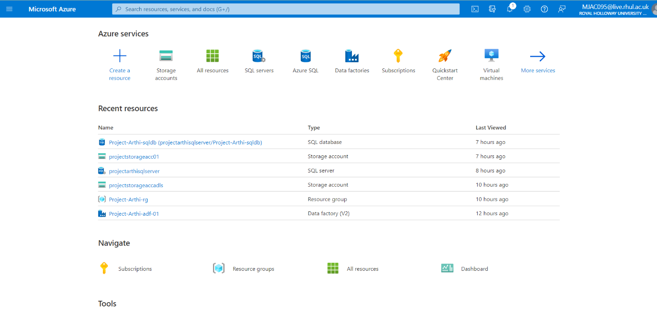

* Create SQL Server and Azure Storage linked services: In SQL Server Management System, created own Database named **Store** containing 7 Tables namely **dbo.Category, dbo.Customer,dbo.Outlet,dbo.Product,dbo.Product_Category, dbo.Purchase, dbo.Purchaseitem,dbo.Stock.**
* Created database and populated the table using insert query values in each table.

### **Screenshot 1.2.a:** Creating DB in SSMS

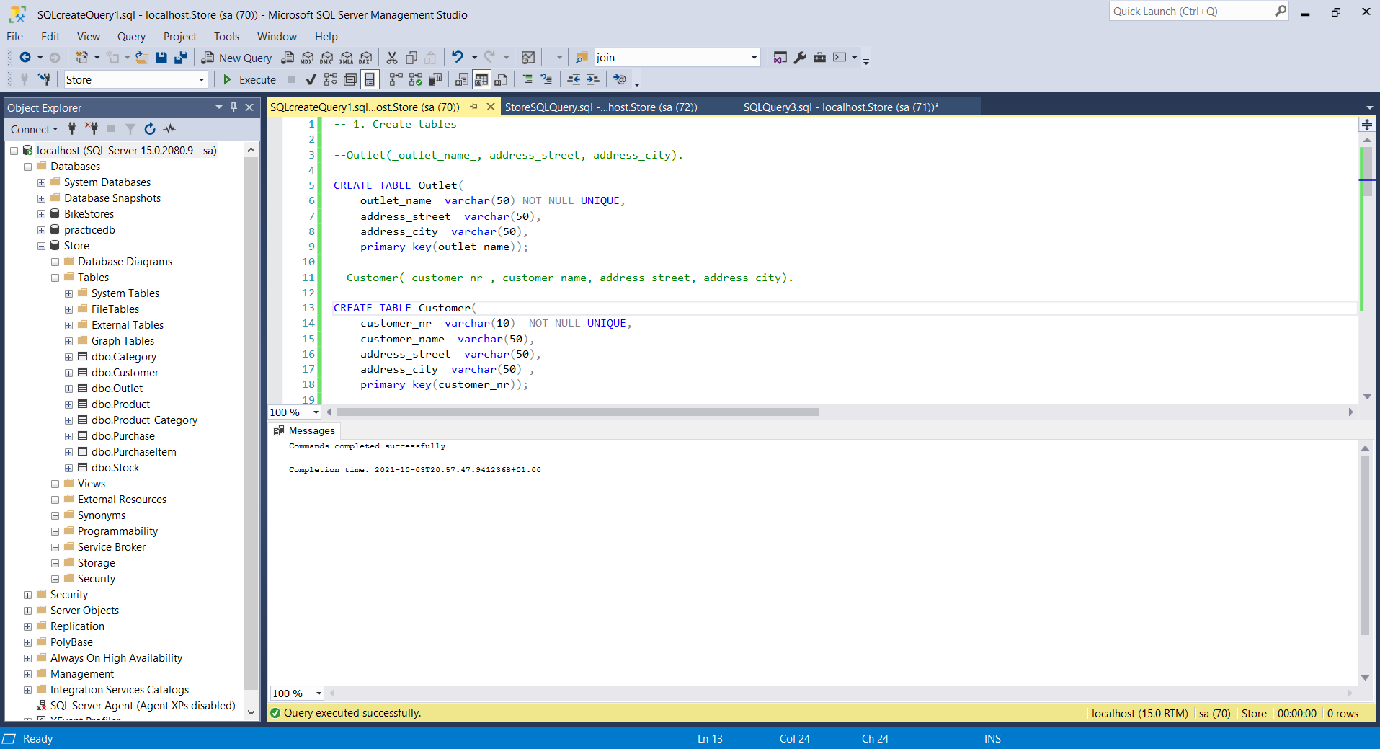

### **Screenshot 1.2.b:** Populating Table using insert query in SSMS

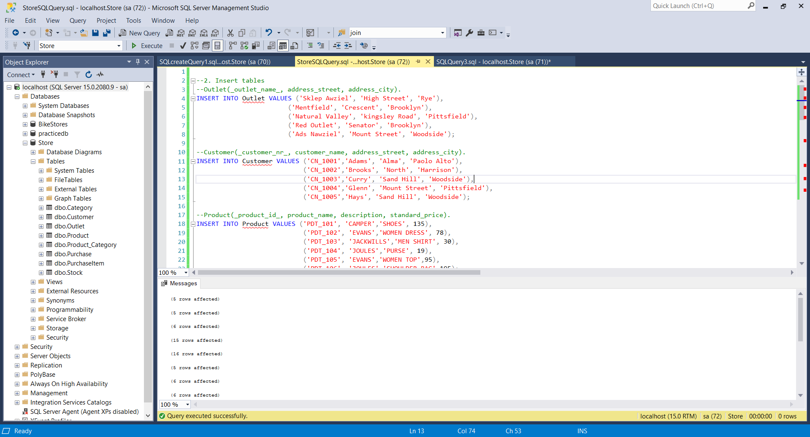

### Screenshot 1.2.c: Verifying the data inserted in Tables

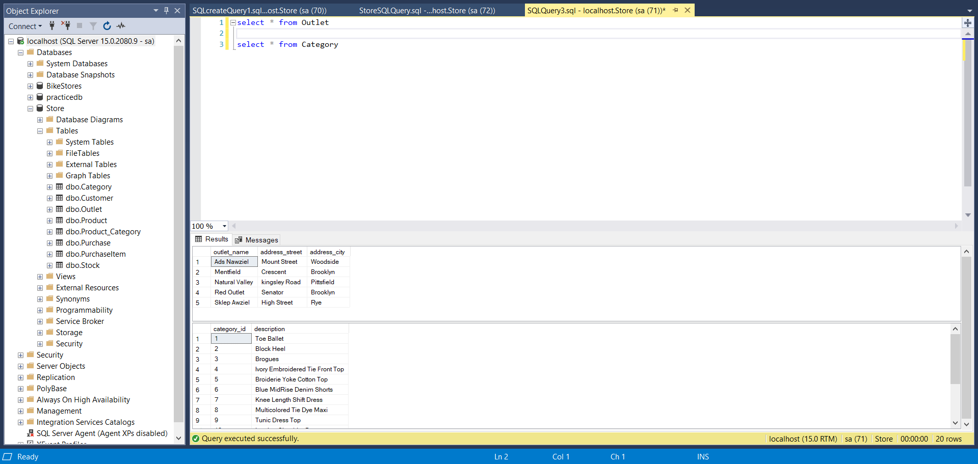

Sample: **dbo.Outlet**

##### -- 1. Create Tables

**--Outlet(_outlet_name_, address_street, address_city).**

**CREATE TABLE Outlet(**

**outlet_name varchar(50) NOT NULL UNIQUE,**

**address_street varchar(50),**

**address_city varchar(50),**

**primary key(outlet_name));**

##### --2. Insert Tables

**--Outlet(_outlet_name_, address_street, address_city).**

**INSERT INTO Outlet VALUES ('Sklep Awziel', 'High Street', 'Rye'),**

**('Mentfield', 'Crescent', 'Brooklyn'),**

**('Natural Valley', 'kingsley Road', 'Pittsfield'),**

**('Red Outlet', 'Senator', 'Brooklyn'),**

**('Ads Nawziel', 'Mount Street', 'Woodside');**

* Created SQL Server and Azure Blob datasets named as **projectstorageacc01 as** showed in Screenshot 1.
* Created a pipeline named **SQLSeverToBlobPipeline** with a copy activity **“CopySqlServerToAzureBlobActivity”** to move the data from on-premises to blob storage. Then set up Source dataset: **SqlServerDataset.**

### Screenshot 1.3.a: Displays both Pipelines, Copy Activity and Source Dataset

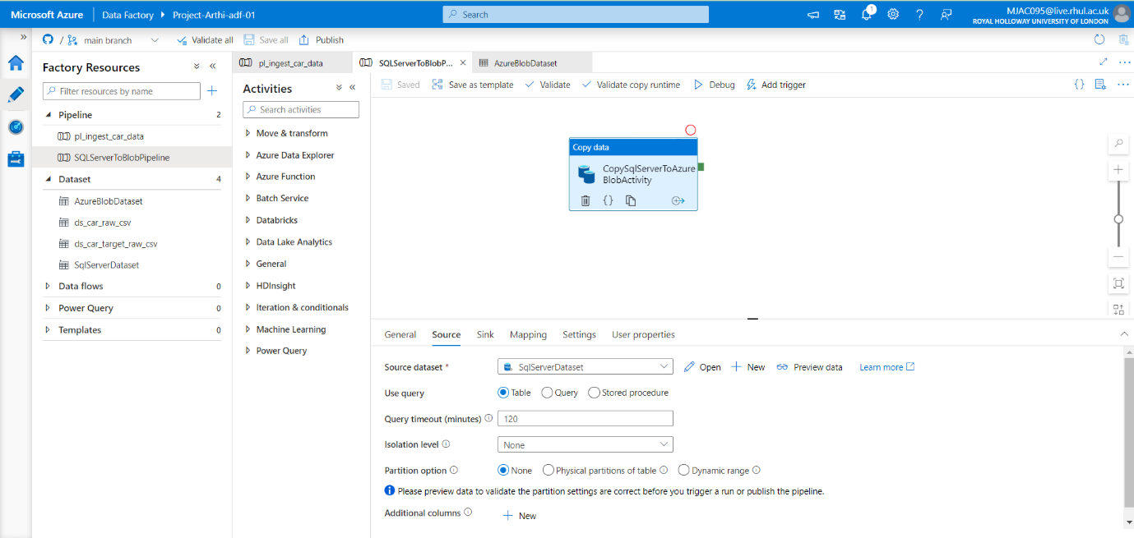

* Sink dataset as: **AzureBlobDataset, created file path as myblob / Directory: fromonprem/ File: @CONCAT(pipeline().RunId, '.txt'),** to rename file as PipelineRunID.txt.

### Screenshot 1.3.b: Displays Sink Dataset

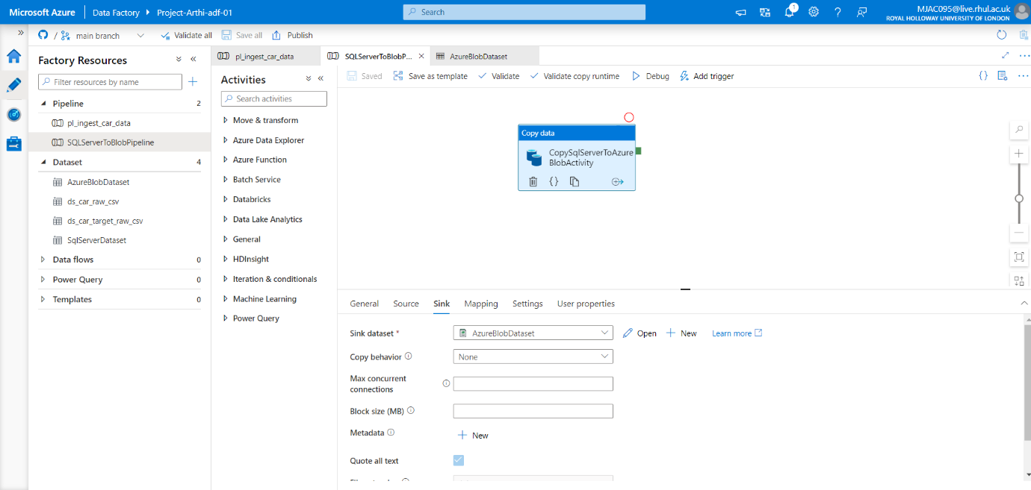

* If the file section adds dynamic content not given user, it will automatically get the filename from the copied data.
* Started a pipeline run, debugged, pipeline validation done. Published All

### Screenshot 1.4.a: Pipeline Activity Details

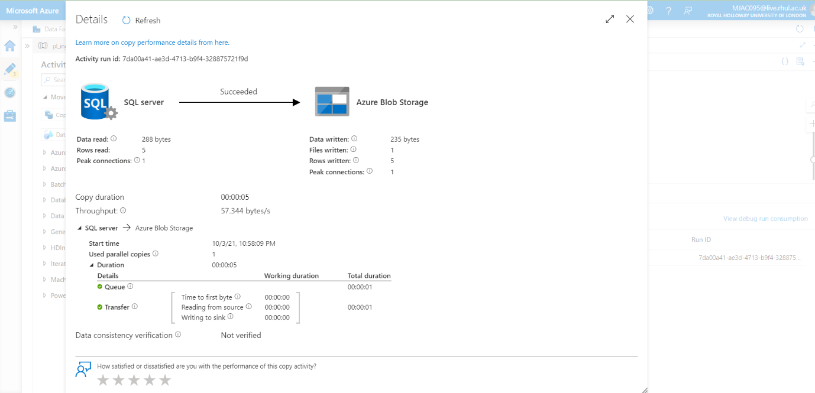

### Screenshot 1.4.b: Pipeline Debug Details

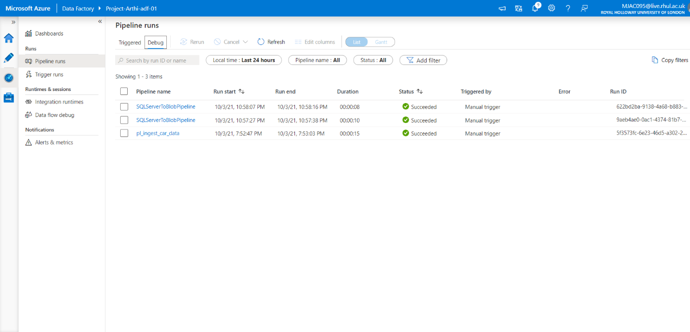

* Added trigger by clicking on trigger now
* Monitoring the relative pipeline SQLServerToBlobPipeline

### Screenshot 1.4.c: Pipeline Manual Trigger Details

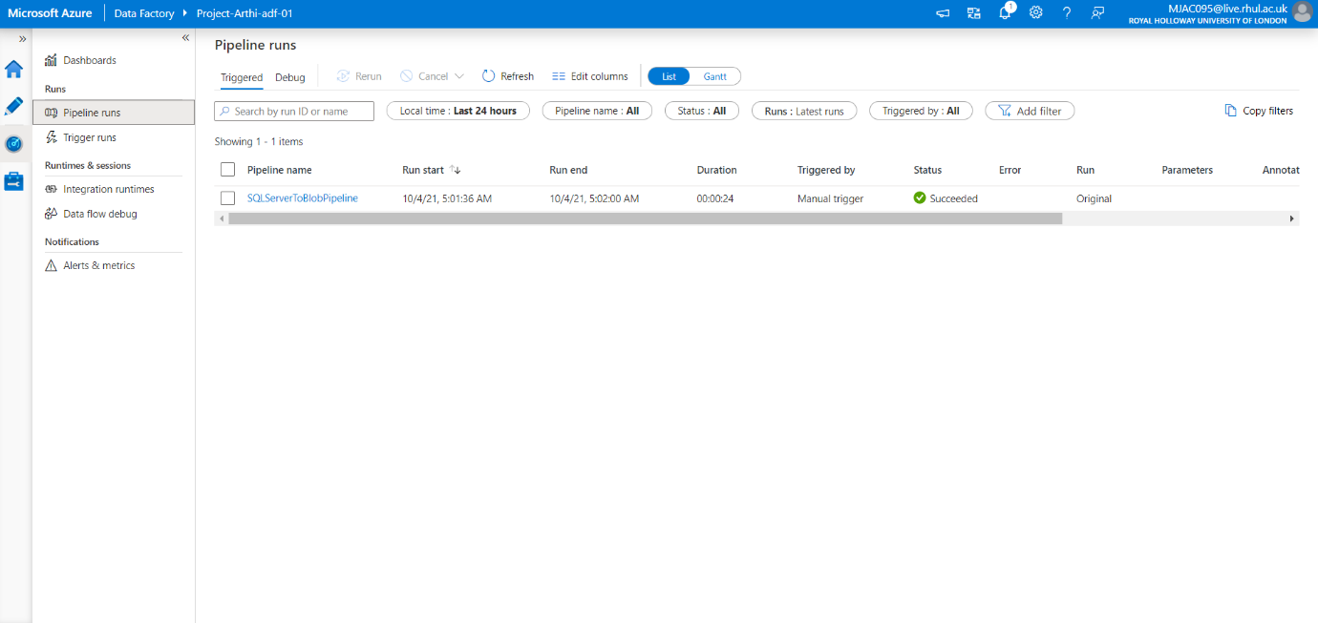

* Output verified: Table copied to Azure blob storage as .txt file.

### Screenshot 1.5: Output Verification

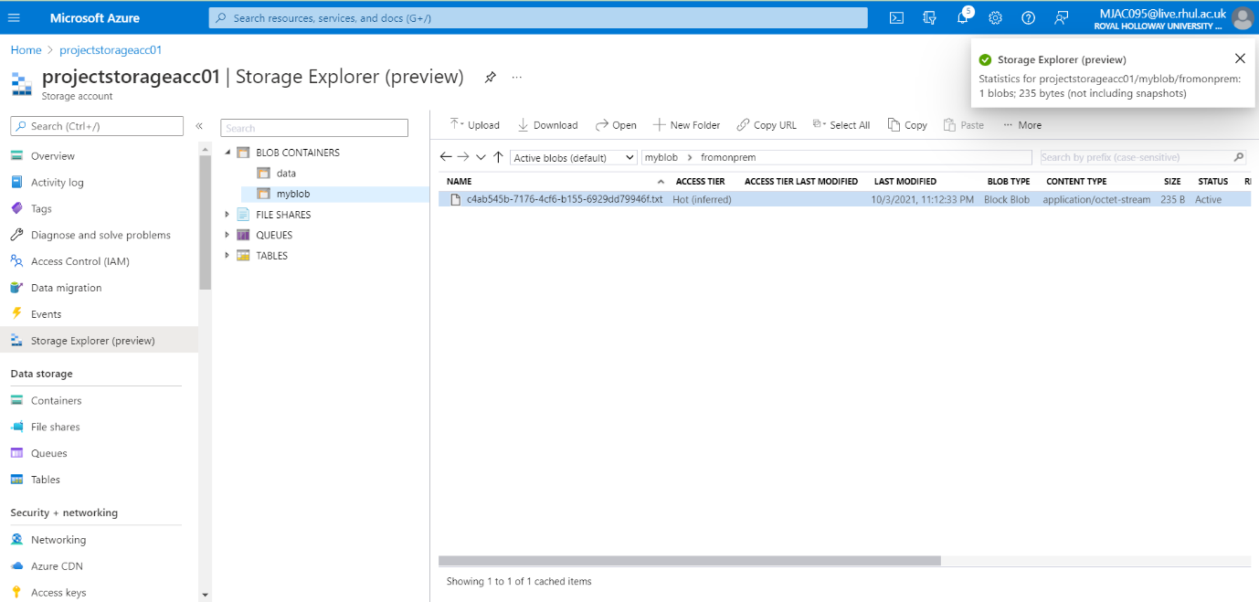

Files: Output text files for this Problem in Solution1 Folder.

**=================================================================**

Problem Statement 2: **Ingest data from multiple Tables in SQL Server database to Azure Synapse Analytics**

**=================================================================**

## Solution :

* Created a Resource group, named as: Project-Arthi-rg
* Created a Blob Storage Account, named as: projectstorageacc01
* Created Azure Synapse Workspace named as: synapseclassworkspace
* In the Synapse Workspace, click Ingest:
* Copy Data Tool is Displayed
* Chose Built-in copy Task

### Screenshot 2.1: Displays Properties Tab of Copy Data Tool

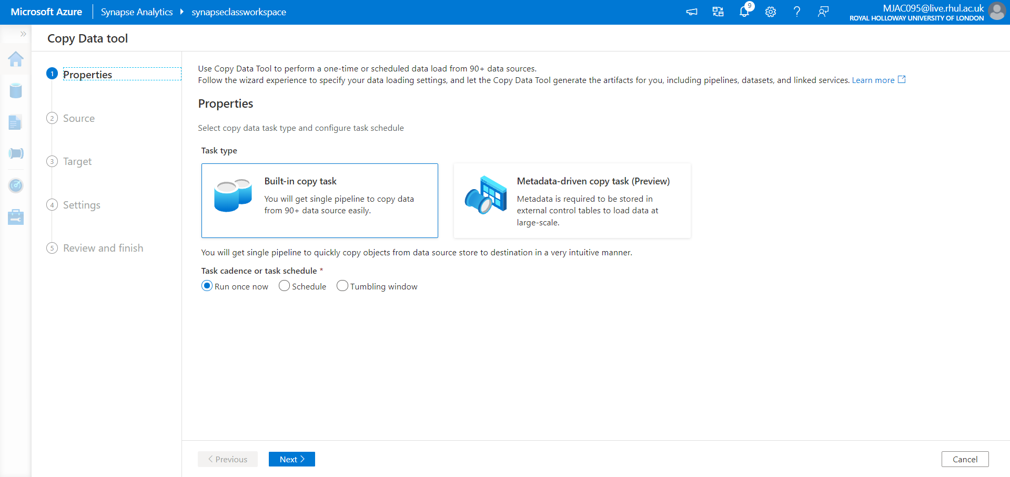

* In the Source Tab,
  + Choose Source Type: Azure SQL Database
  + Choose Connection: AzureSqlDatabse
  + Source Tables: chose existing Tables,
    - entered “SalesLT”
    - Select check box SelectAll

### Screenshot 2.2.a: Displays Source Tab of Copy Data Tool

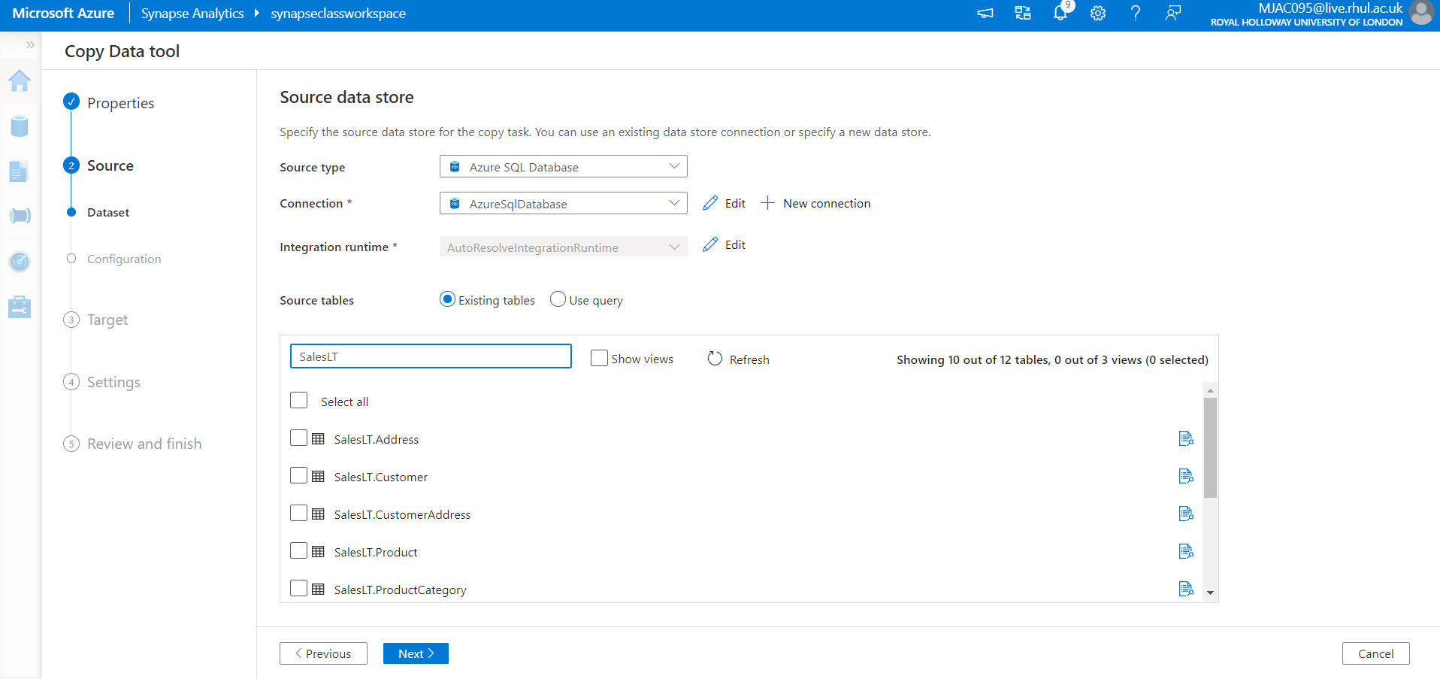

### Screenshot 2.2.b.: Displays Preview Data for all the Tables of SalesLT

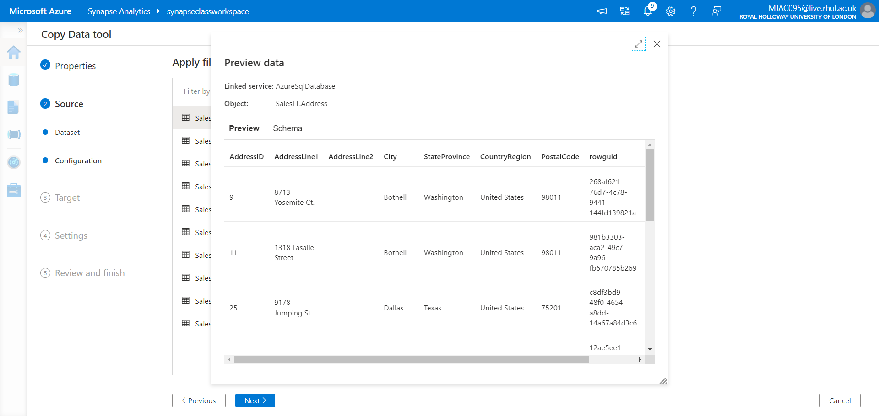

* In the Target Tab,
  + Choose Source Type: Azure Synapse Analytics
  + Choose Connection: AzureSynapseAnalytics
    - Choose server name: synapseclassworkspace.sql.azuresynapse.net
    - Database: dedicatedpool
* In the Destination Data Store:
  + Table mapping should be done,
  + Column mapping has to be done,
  + Deselect Type conversion.

### Screenshot 2.3: Displays Sink Data Linked Service, Server Name, Dedicatedpool

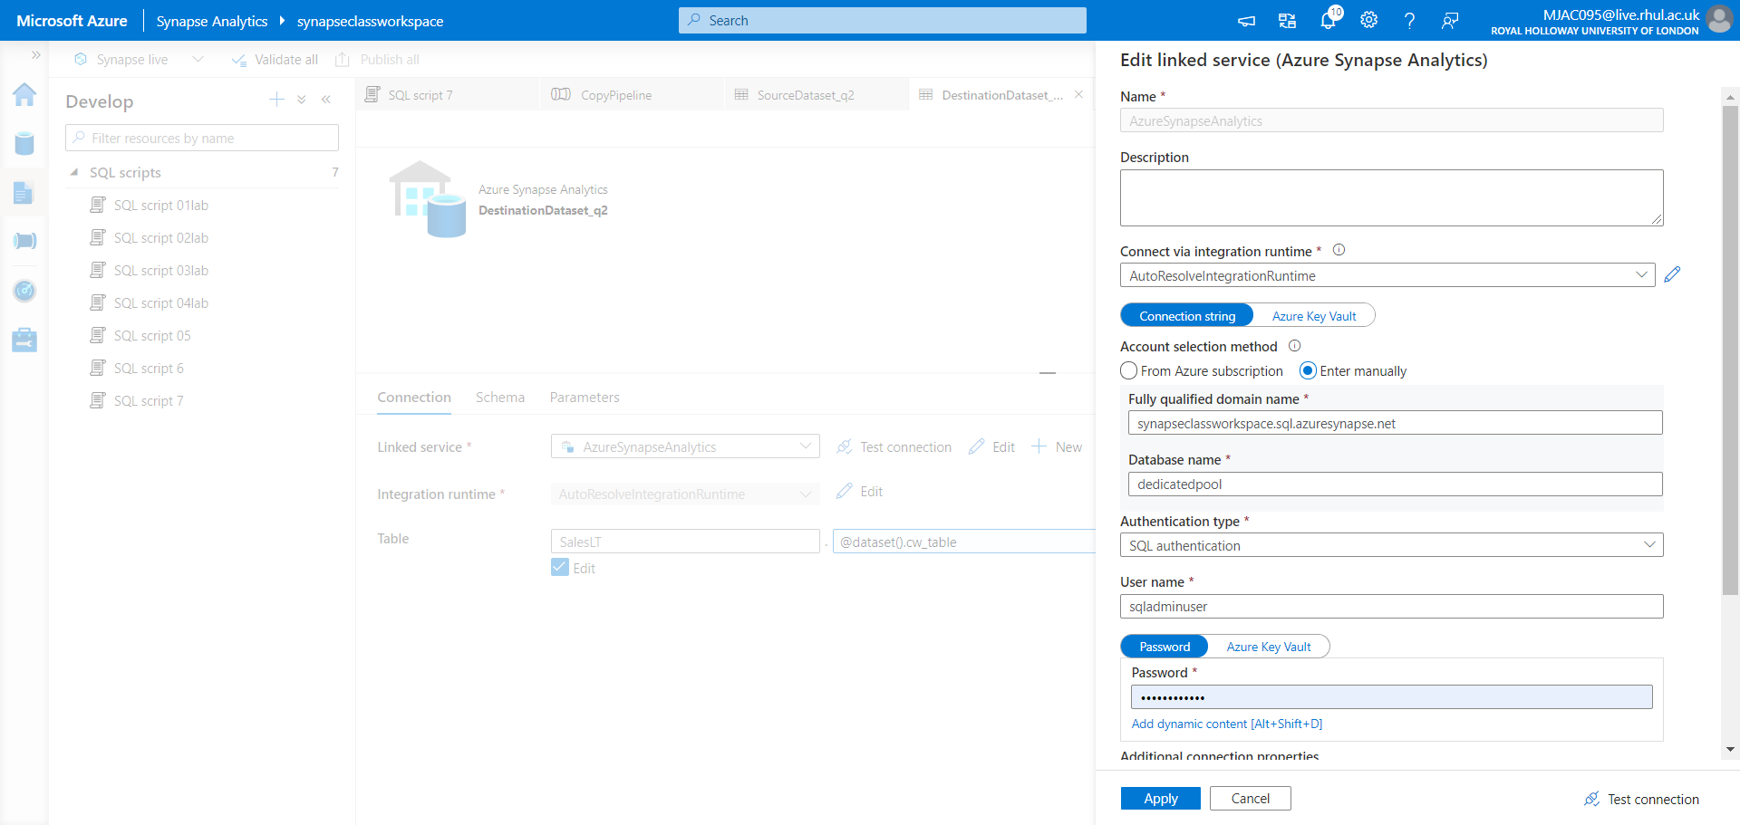

### Screenshot 2.4.a: Displays Table Mapping Source to Sink

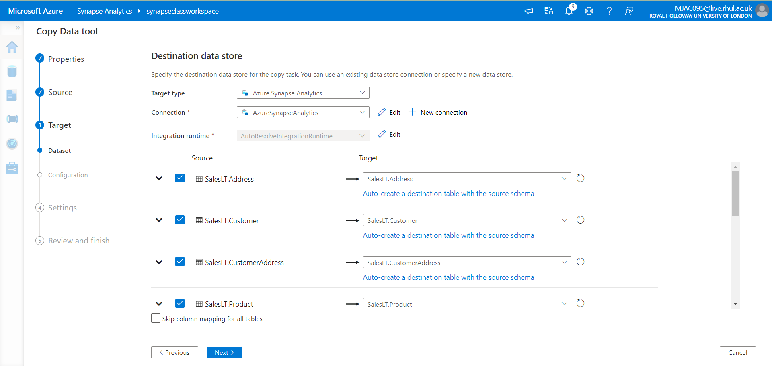

### Screenshot 2.4.b: Displays Column Mapping Source to Sink

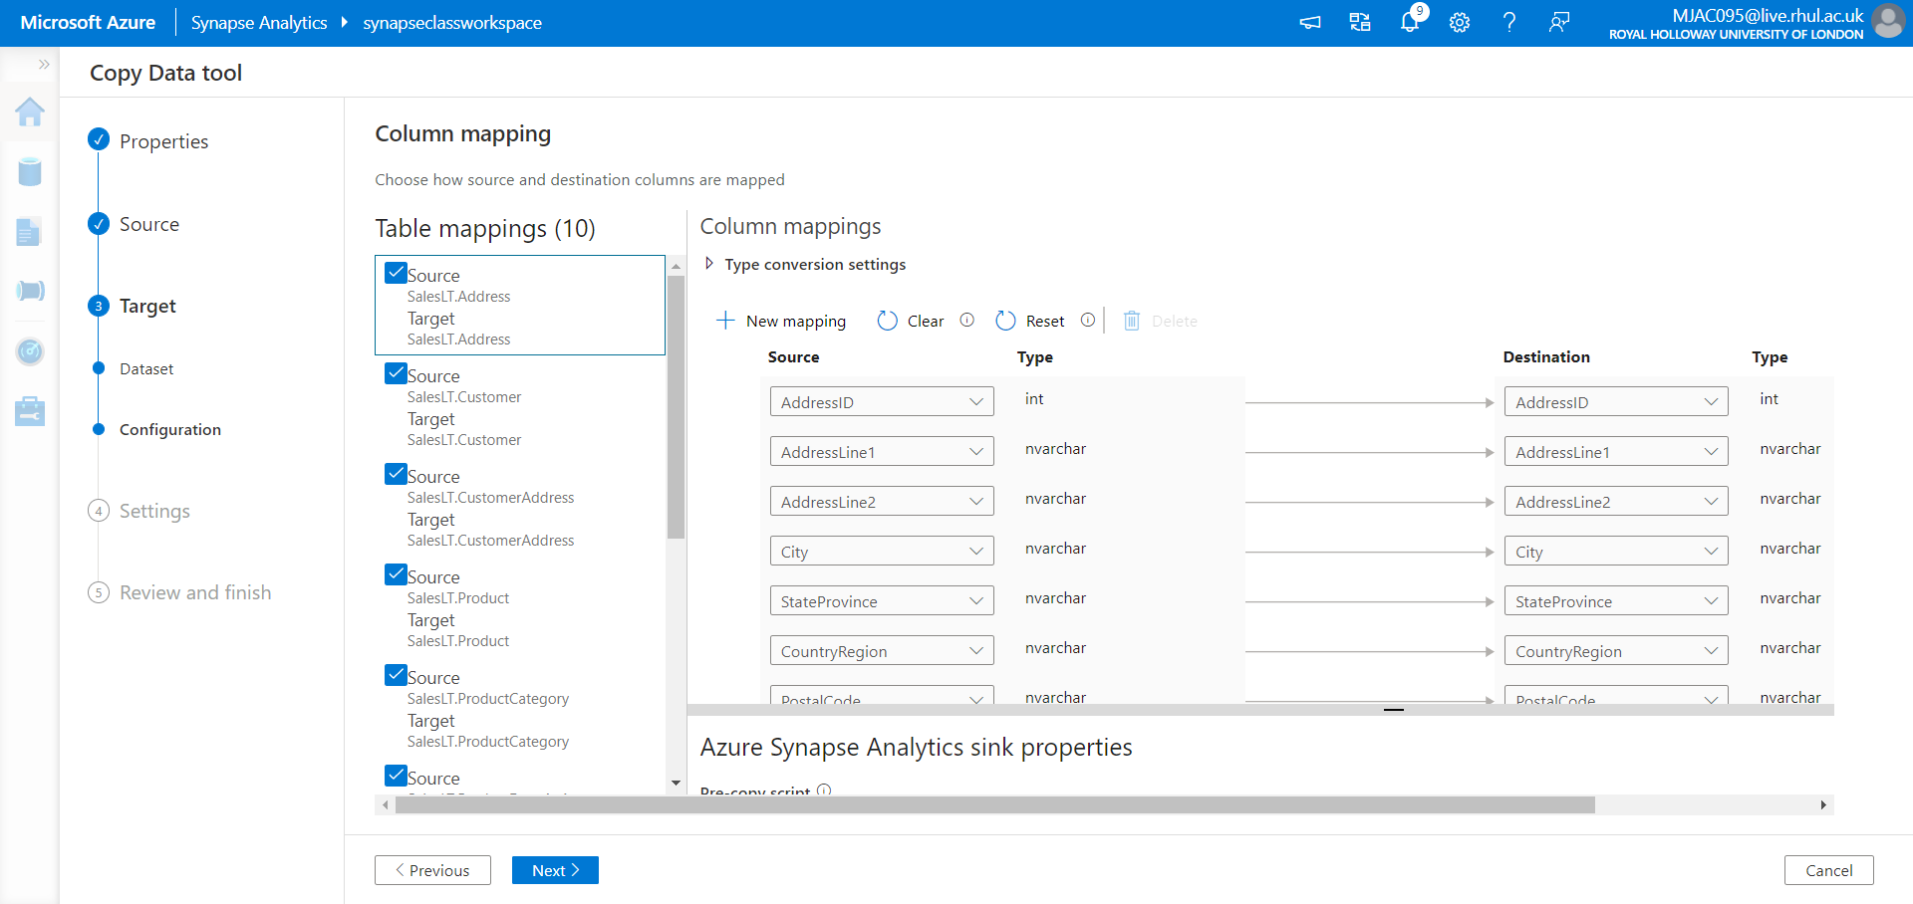

* The storage is used for staging the data before it loads into Azure Synapse Analytics by using PolyBase.
* After the copy is complete, the temporary data in Azure Blob Storage is automatically cleaned up.

### Screenshot 2.5: Displays Settings Page, Staging, Linked Service, PolyBase setting

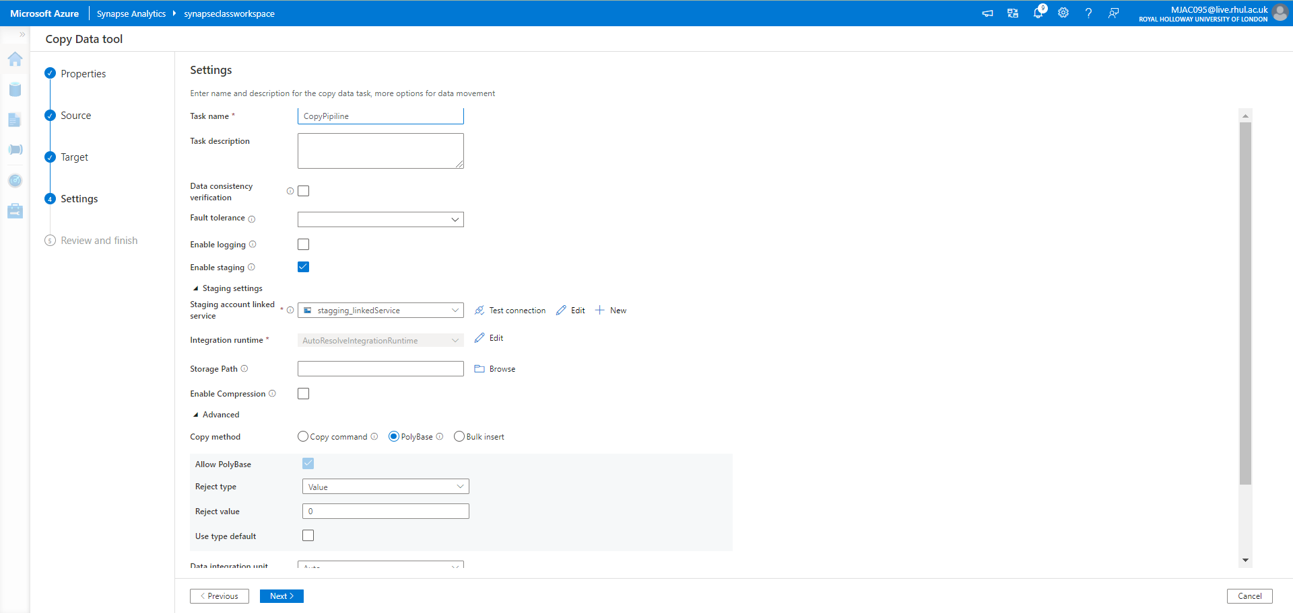

### Screenshot 2.6: Displays Summary Page

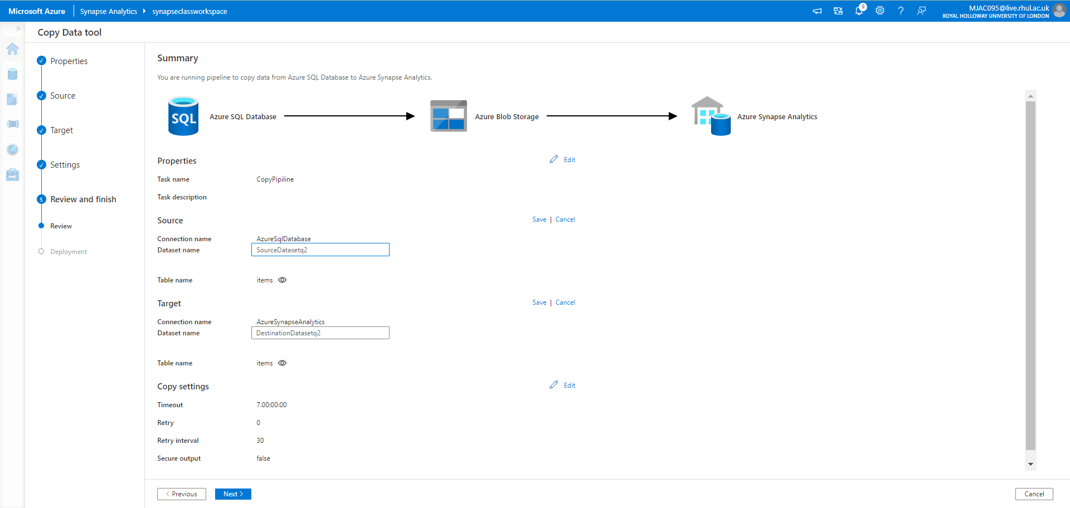

* Now, we have created the required datasets and pipeline settings,

### Screenshot 2.7: Displays Summary Page

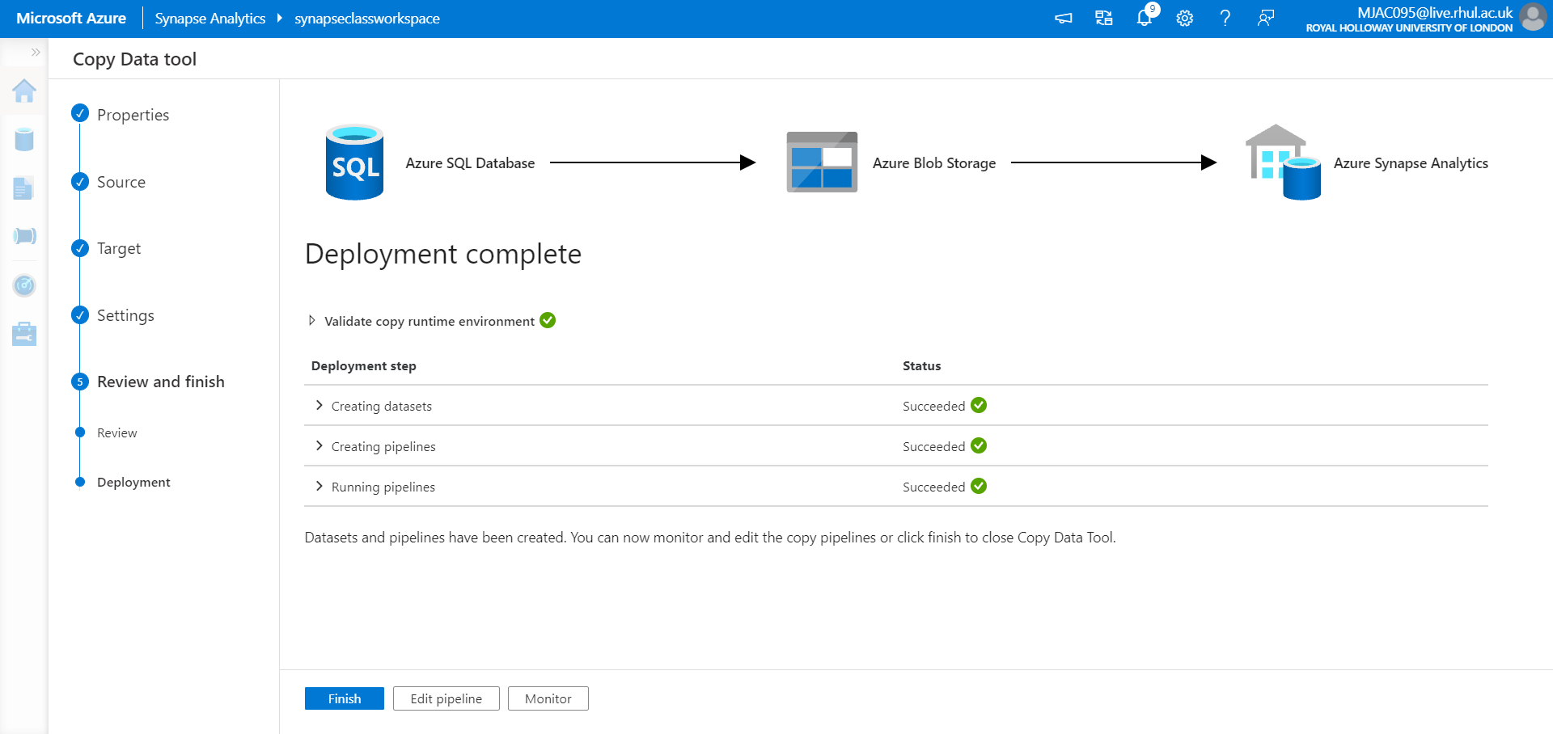

### Screenshot 2.8: Displays Pipeline Monitoring

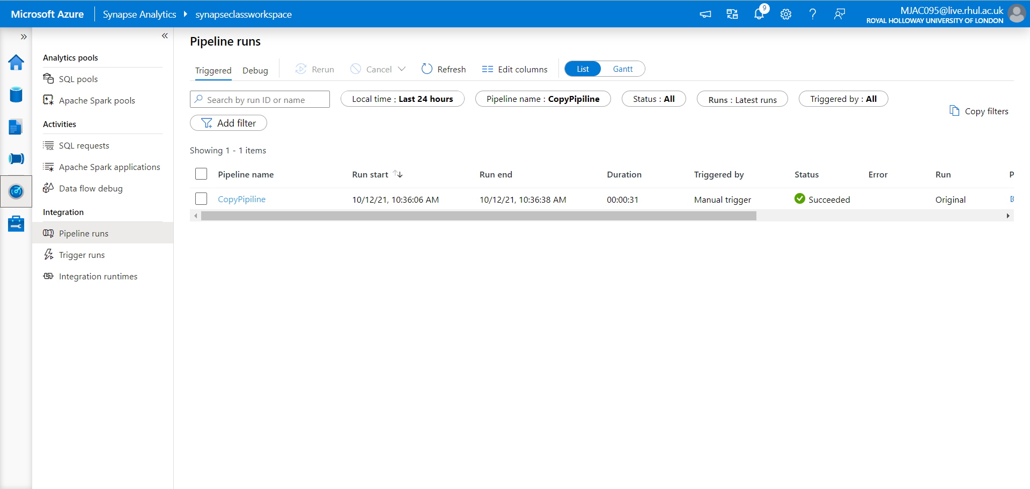

* In the below Screenshot below, we could see all the Tables are copied into the Tables,

### Screenshot 2.9: Displays Pipeline Debug Details

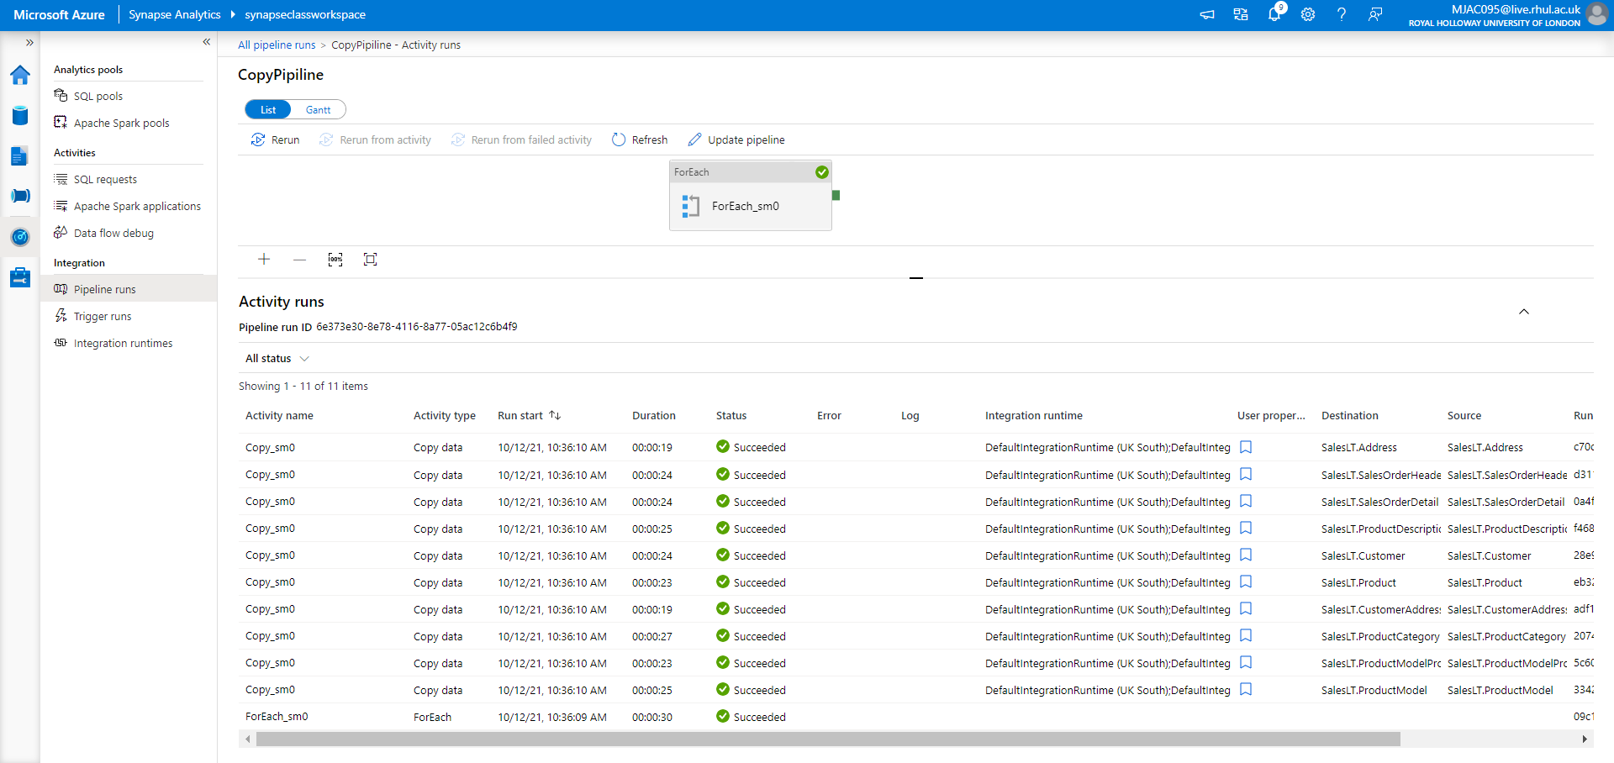

* Output verified: Using select query in any one of the tables and view the records

### Screenshot 2.10: Output Verification

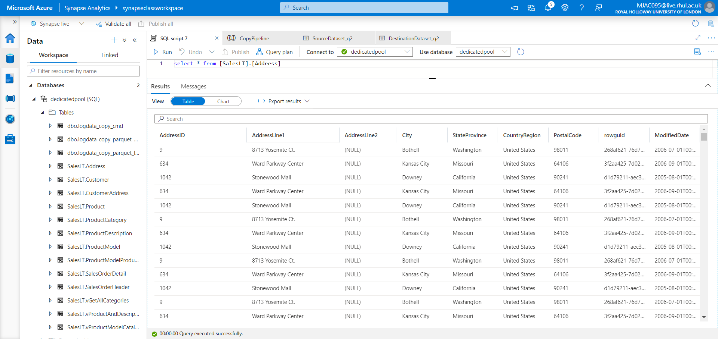

**=================================================================**

Problem Statement 3: **Load data from Azure Blob storage to a database in Azure SQL Database by using Azure Data Factory**

**=================================================================**

## Solution:

* Created a Resource group, named as: Project-Arthi-rg
* Created a Blob Storage Account, named as: projectstorageacc01
* Created a data factory, named as: Project-Arthi-adf-01
* Created a self-hosted integration runtime named as: IR-1

as shown in Screenshot1.1.

* Created a Blob Storage and SQL table as **Source**

Created a Outel.txt file and uploaded in **myblob – container / input – folder / Outlet.txt**

### TextFile :

|  |
| --- |
| **Outlet.txt** |
|  |
| outlet_name,address_street,address_city  Sklep Awziel,High Street,Rye  Mentfield,Crescent,Brooklyn  Natural Valley,kingsley Road,Pittsfield  Red Outlet,Senator,Brooklyn  Ads Nawziel,Mount Street,Woodside |

### Screenshot 3.1: Displays Text File in Blob Storage inside Container

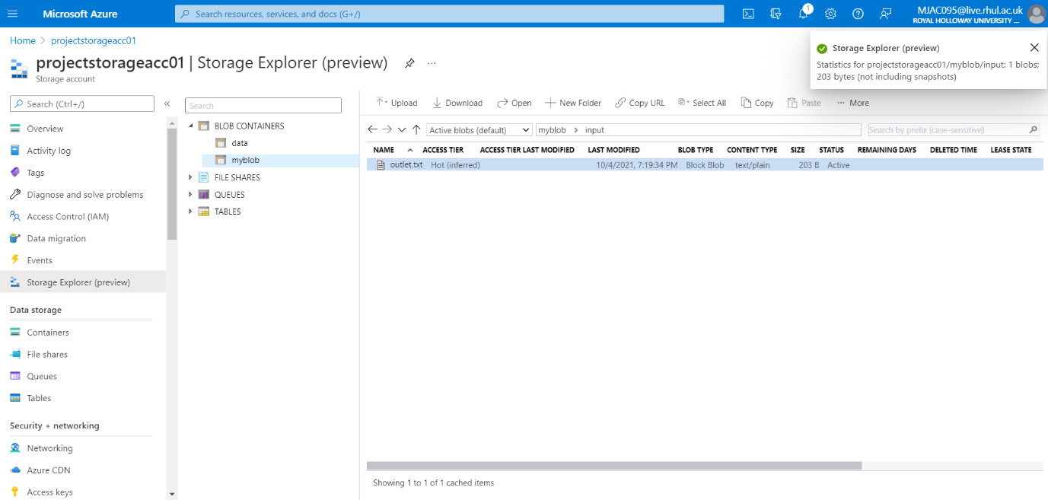

* Created SQL table as **Sink, w**ith the following SQL script: **dbo.outlets**

Query: dbo.outlets

CREATE TABLE dbo.outlets(

ID int IDENTITY(1,1) NOT NULL,

outlet_name varchar(50) NOT NULL,

address_street varchar(50),

address_city varchar(50),

primary key(ID));

GO

CREATE CLUSTERED INDEX IX_outlet_ID ON dbo.outlets (ID);

* In case of if any attribute is given unique, it creates integration violation, so we drop and truncate table and create a new one using above SQL script.

DROP TABLE dbo.outlet1

TRUNCATE TABLE dbo.outlet1

* Created a pipeline named CopyPipeline with a copy activity **“** CopyFromBlobToSql**”** to move the data from blob storage to Azure SQL database. Then set up Source dataset: SourceBlobDataset with linked service AzureStorageLinkedService

### Screenshot 3.2.a: Displays both Pipelines, Copy Activity and Source Dataset

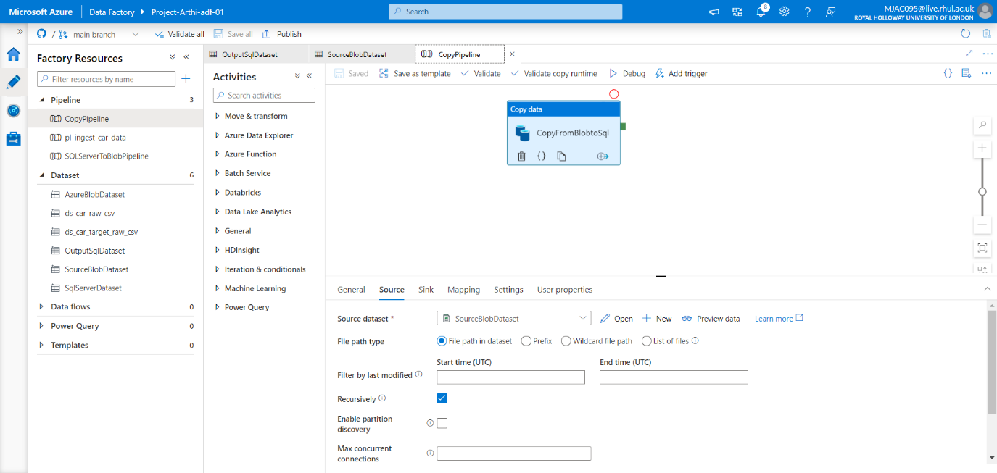

* Sink dataset as:OutputSqlDataset (Azure SQL database) **,** with linked service AzureSqlDatabaseLinkedService

### Screenshot 3.2.b: Displays Sink Dataset

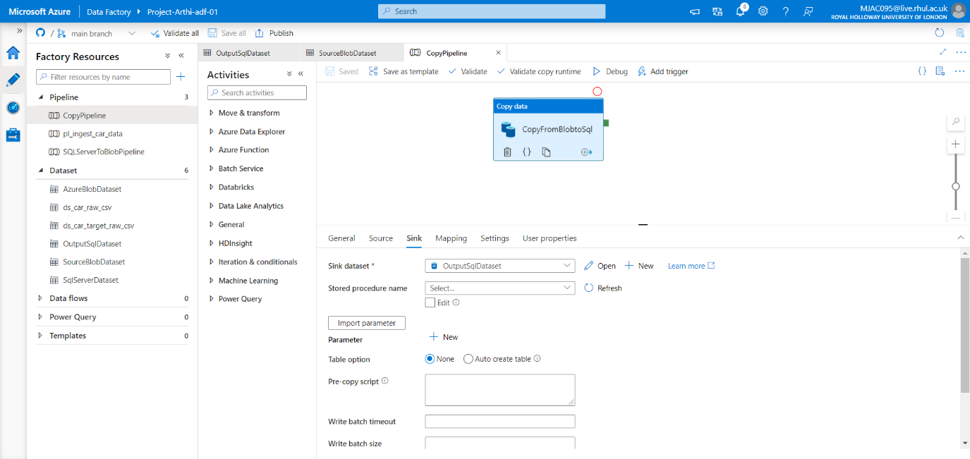

* Started a pipeline run, debugged, pipeline validation done. Published All

Screenshot 3.3.a: Pipeline Activity Detail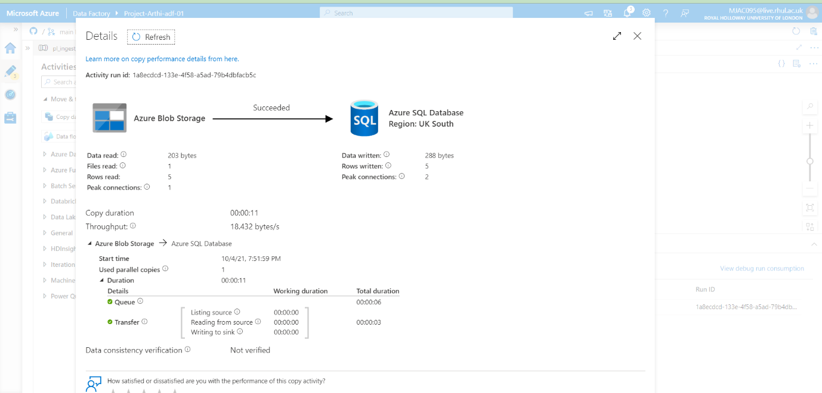

### Screenshot 3.3.b: Pipeline Debug Detail

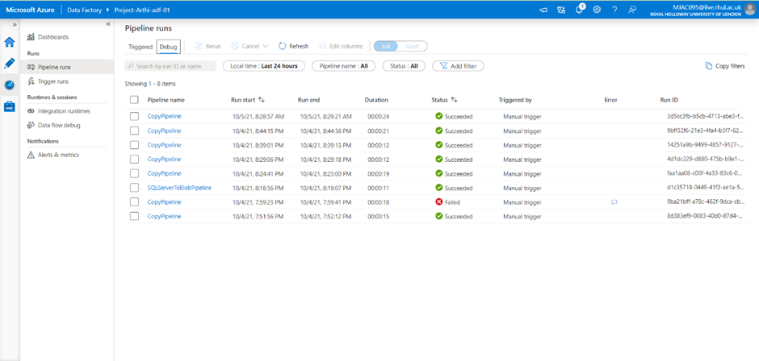

* Added trigger by clicking on trigger now
* Monitoring the relative pipeline CopyPipeline

### Screenshot 3.3.c: Pipeline Manual Trigger detail

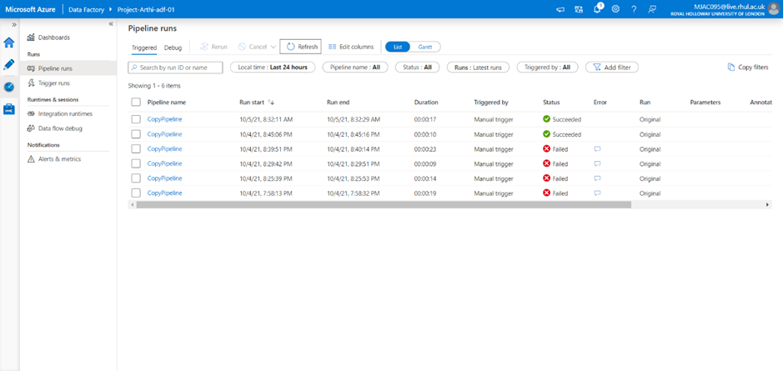

* Output verified: Text File copied from Azure blob storage to a Table format in Azure SQL database.
* Verified using SQL SCRIPT:

SELECT * FROM [dbo].[outlets]

* When the copy activity performed for first time, text file 5 rows copied into table as first row as header and next 5 rows as 5 records.
* When we triggered, text is copied into table, therefore next 5 recodes are created in the table with ID 6-10.

### Screenshot 3.4: Text File copied from Azure Blob Storage to Azure SQL Database

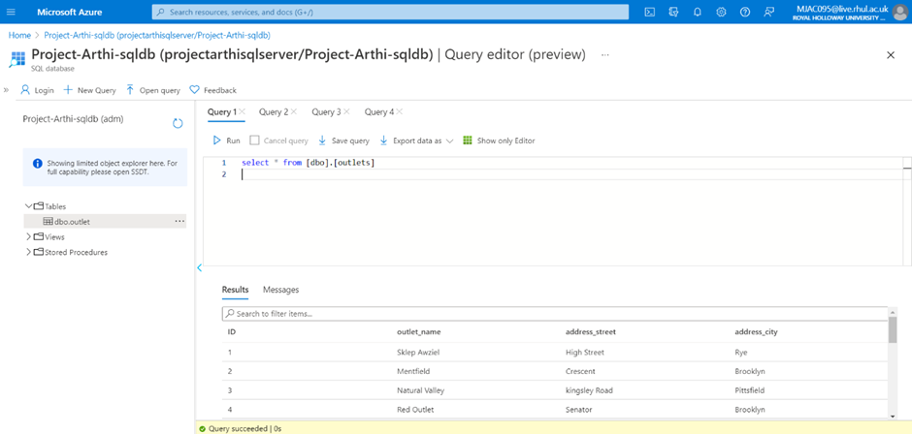

### Screenshot 3.5: Output Verification

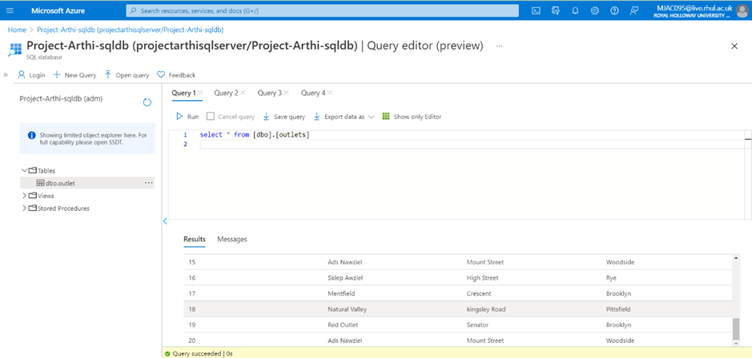

**=================================================================**

Problem Statement 4: **How to Load Multiple Files in Parallel in Azure Data Factory**

**=================================================================**

## Solution :

* Created a Resource group, named as: Project-Arthi-rg
* Created a Blob Storage Account, named as: projectstorageacc01
* Created a data factory, named as: Project-Arthi-adf-01
* Created a self-hosted integration runtime named as: IR-1 as shown in Screenshot 1.
* My Source file contains 3 Top movie name files, 2 semicolon Delimited with 100 values, 1 comma delimited with 50 values.
* These files uploaded in the Blob storage account
  + projectstorageacc01
    - /Container: moviedata
      * /Folder: semicolon (2 files)
        + comma (1 files)

### Screenshot 4.1.a: Displays the Semicolon Delimited Files in Blob Storage

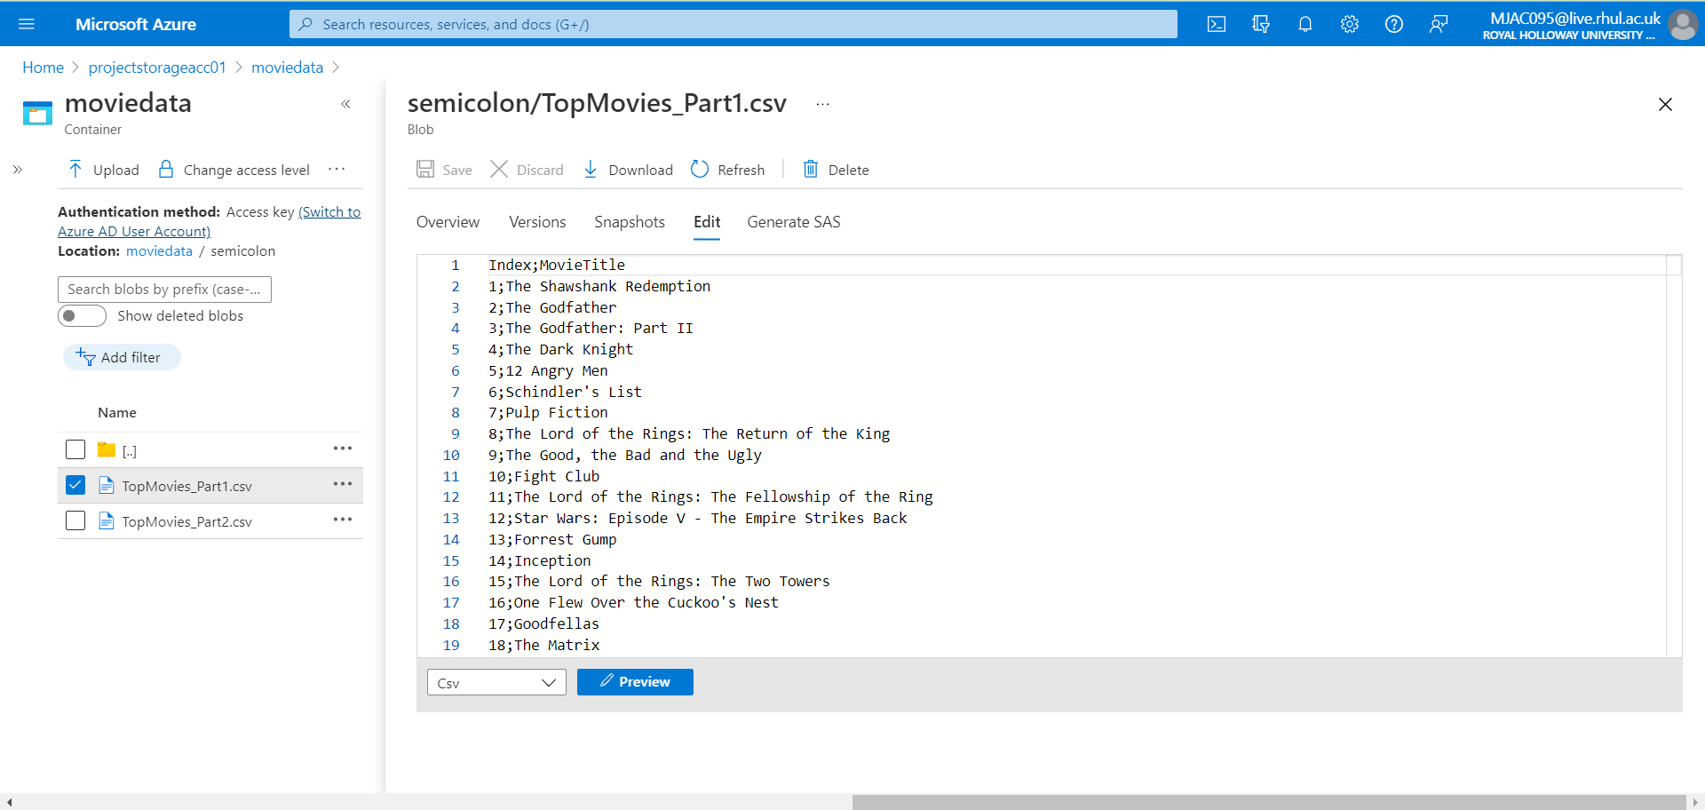

### Screenshot 4.1.b: Displays the Comma Delimited Files in Blob Storage

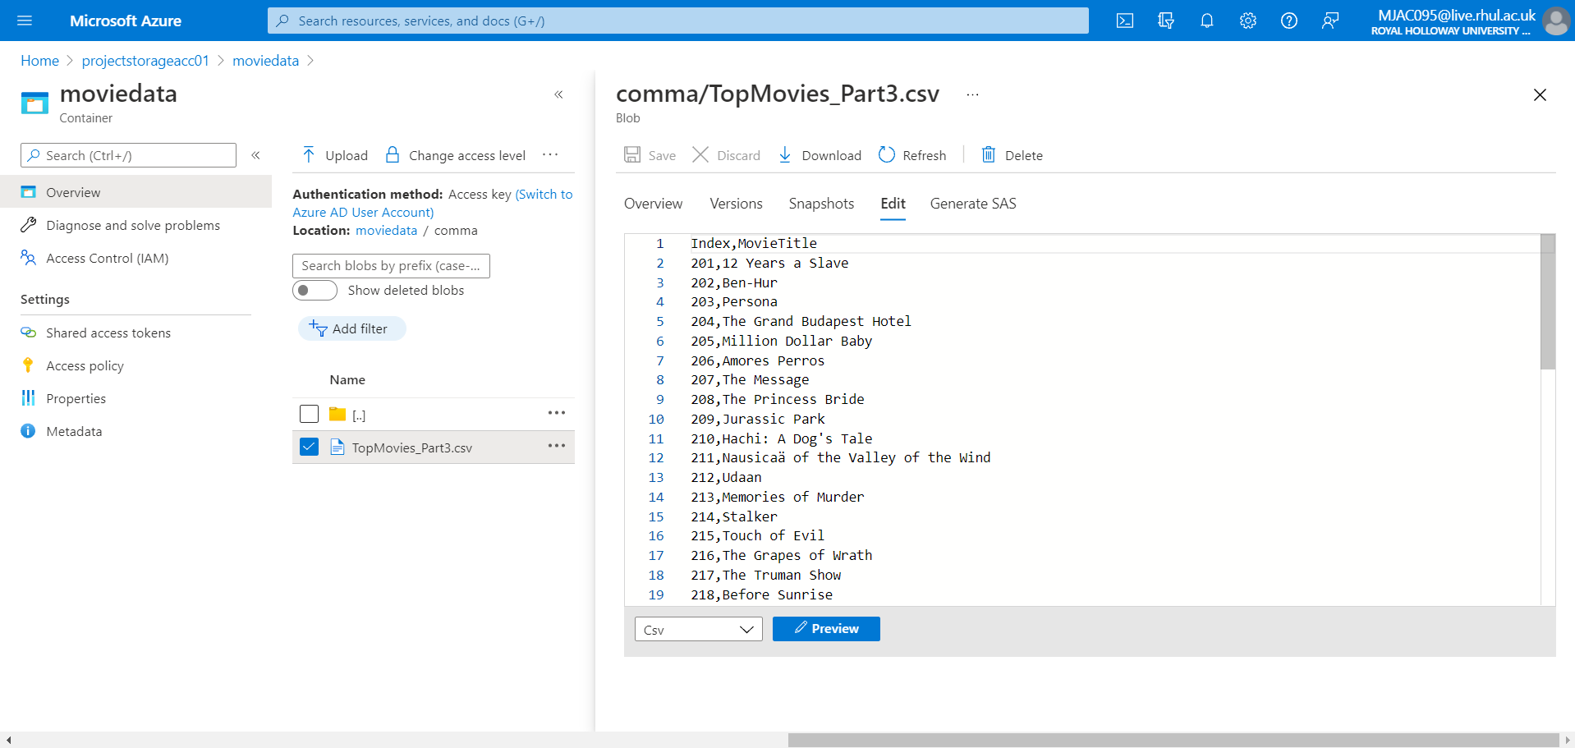

* Metadata for these files are stored in the
  + Azure SQL Database named: Project-Arthi-sqldb,
  + Azure SQL Server named as: projectarthisqlserver
  + Schema for the dbo.Metadata_ADF is stored in a table as key-value pair.
  + Insert queries of the Metadat_ADF, and Destination Table queries is attached with project in the Solution 4 folder.
* Created 2 datasets. One for blob storage and one for SQL Server.
* Source Dataset named as: ds_movies_dynamic_csv
  + Created Linked Service: ls_movies_dynamic_q4
  + Need to add Parameters as FolderName and Delimiter symbol
  + Set the file path:
    - movidata/@dataset()Foldername/File
  + Set the Column delimiter:
    - check edit check box,
    - set: @dataset().DelimiterSymbol

### Screenshot 4.2.a: Displays the Source Dataset

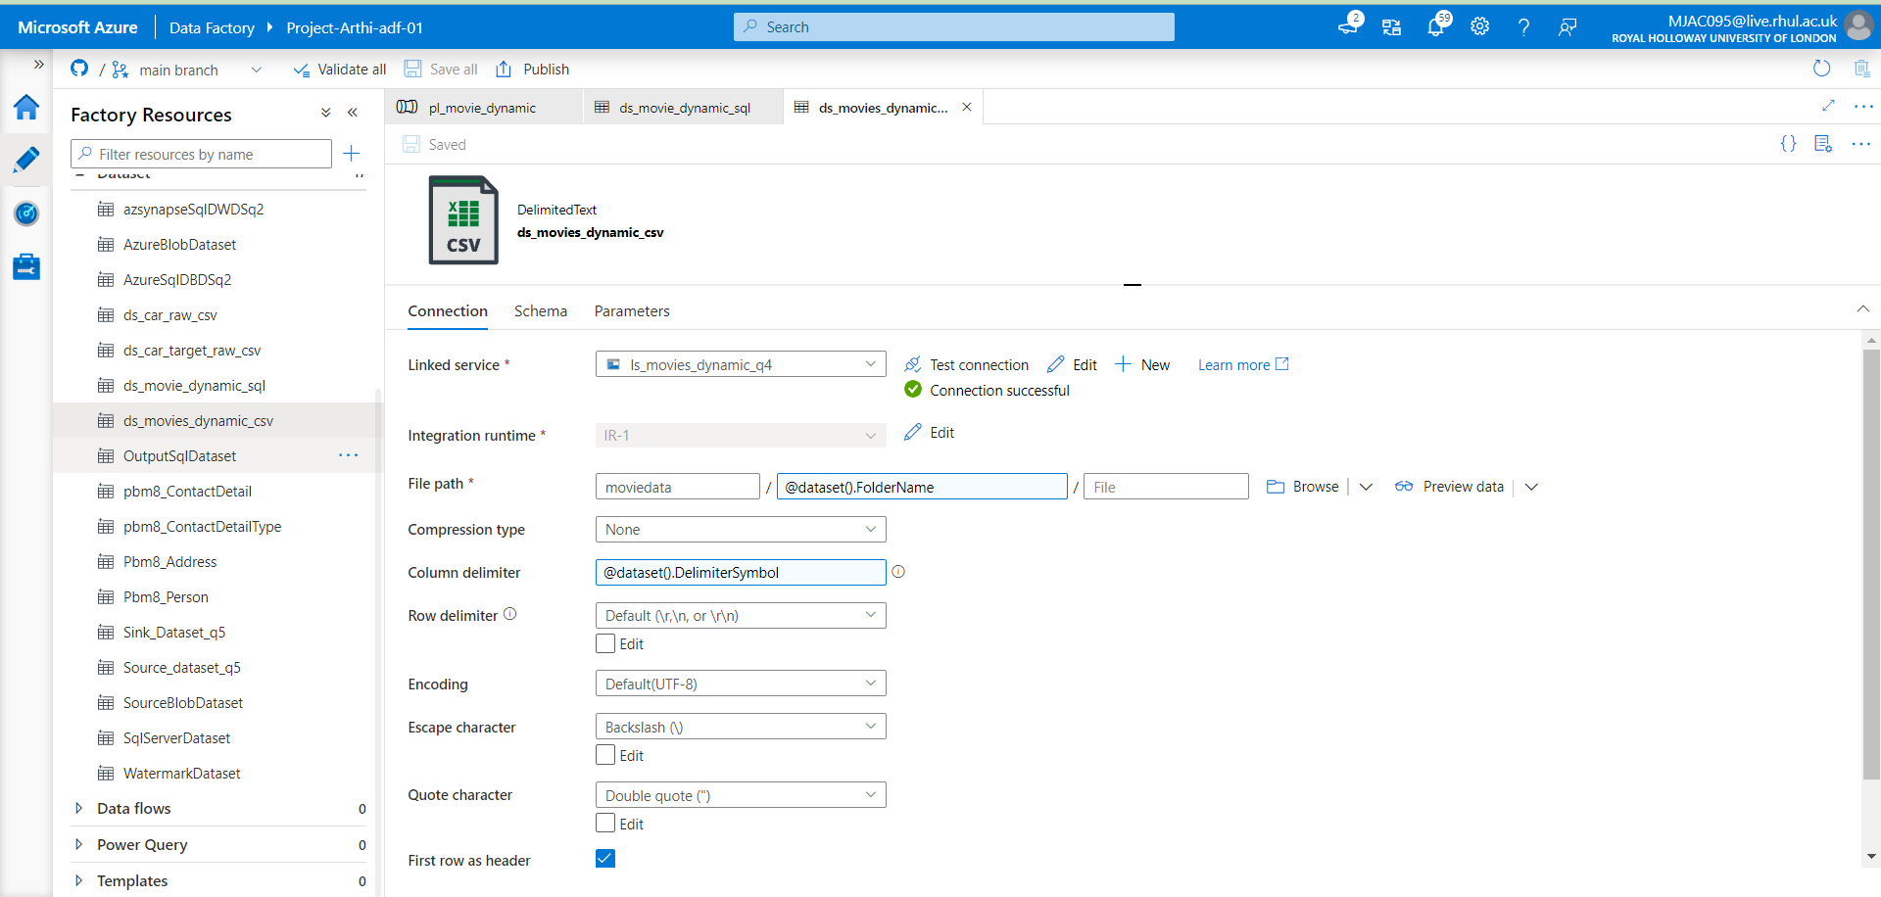

* Sink Dataset named as: ds_movies_dynamic_sql
  + Created linked Service: SQLtest
  + Need to add Parameters as TableName
  + Set theTable:
    - dbo/@dataset()TableName

### Screenshot 4.2.b: Displays the Sink Dataset

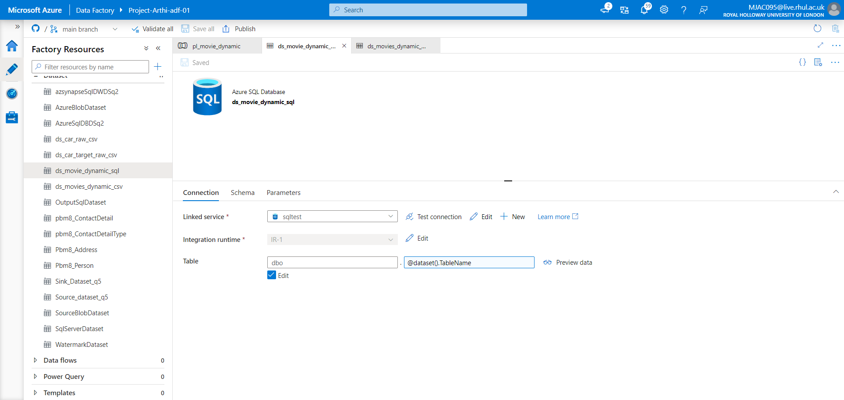

### Screenshot 4.3.a: Displays the Pipeline, Lookup Activity Details

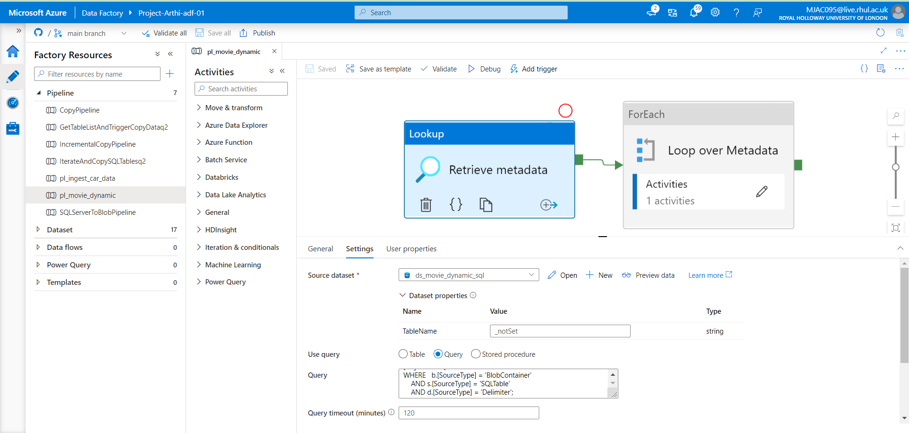

* We connect to the source dataset, set tablename as “_notSet”
* We Use query and deselect the First row only checkbox
* With the following query, we can retrieve the metadata from SQL Server:

### Query:

SELECT

     b.[ObjectName]

    ,FolderName = b.[ObjectValue]

    ,SQLTable   = s.[ObjectValue]

    ,Delimiter  = d.[ObjectValue]

FROM [dbo].[Metadata_ADF] b

JOIN [dbo].[Metadata_ADF] s ON b.[ObjectName] = s.[ObjectName]

JOIN [dbo].[Metadata_ADF] d ON b.[ObjectName] = d.[ObjectName]

WHERE   b.[SourceType] = 'BlobContainer'

    AND s.[SourceType] = 'SQLTable'

    AND d.[SourceType] = 'Delimiter';

### Screenshot 4.3.b: Displays the Preview Data of the Lookup Activity

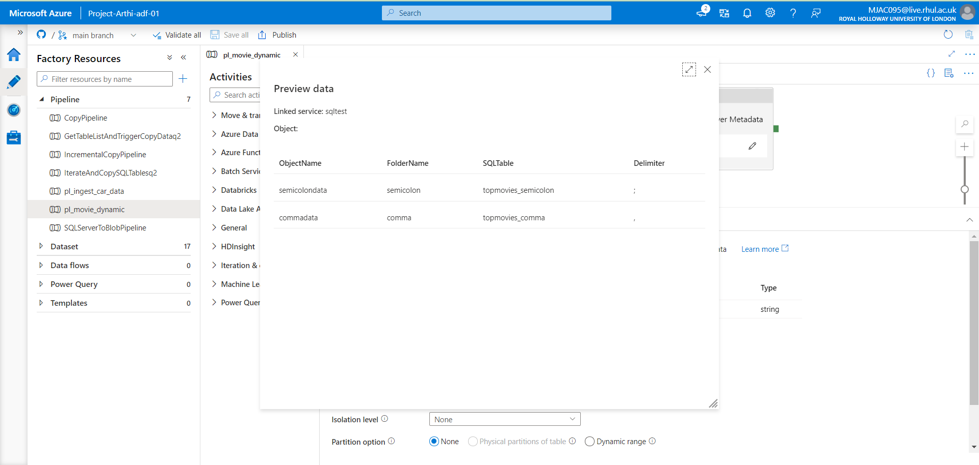

* Next we add ForEach Activity:
  + In Setting tab: set items as : “ @activity('Retrieve Metadata').output.value “ as dynamic content
  + In Activities tab : Add Copy Activity : Copy Blob to SQl
    - Set Source dataset : ds_movies_dynamic_csv
      * Fill the dataset Properties as @(item().FolderName}, @(item().Delimeter}
      * Choose WildcardPath, set wildcard filename as “ *.csv”
    - Set Sink dataset: ds_movies_dynamic_sql
      * Fill the dataset Properties as @(item().TableName}
      * Table Option: None
      * Pre-Copy script:

TRUNCATE TABLE dbo.@{item().SQLTable}

### Screenshot 4.3.c: Displays the Source Dataset Copy Activity within ForEach Activity

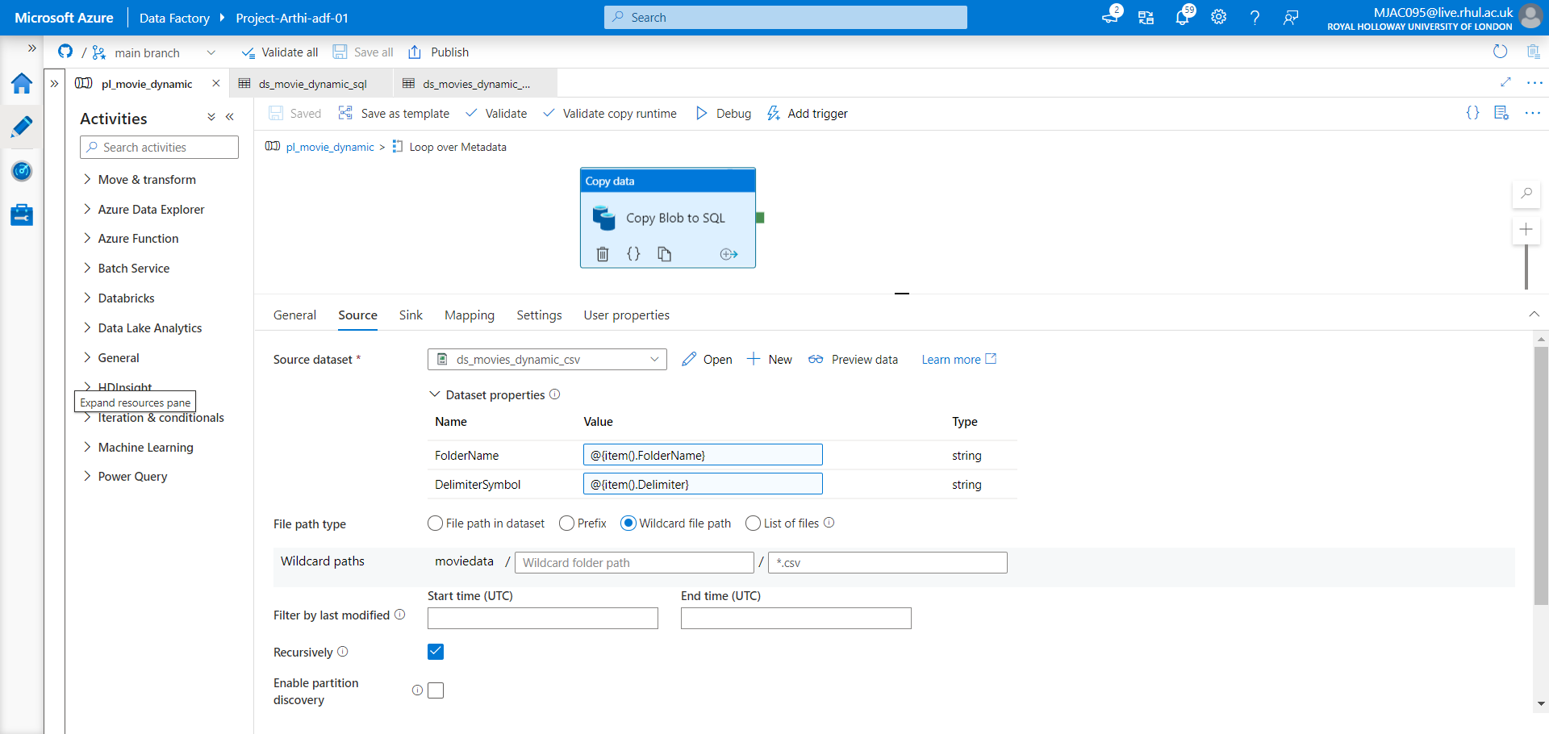

### Screenshot 4.3.d: Displays the Sink Dataset Copy Activity within ForEach Activity

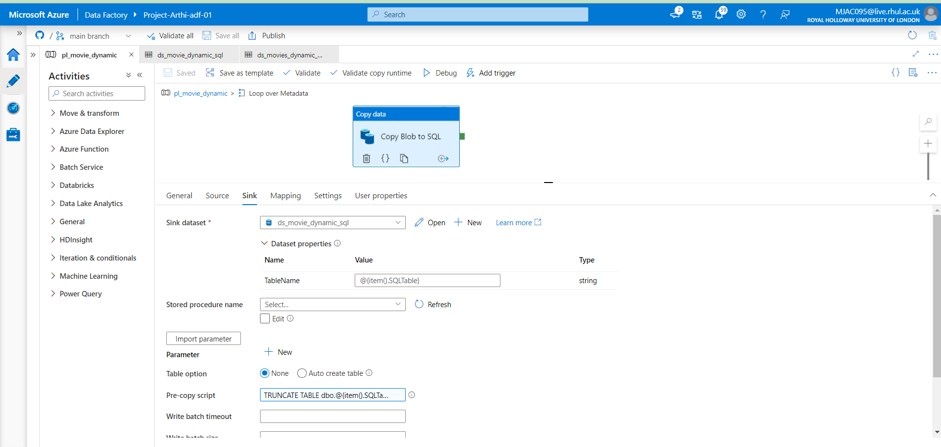

Screenshot 4.4: Pipeline Debug Details  
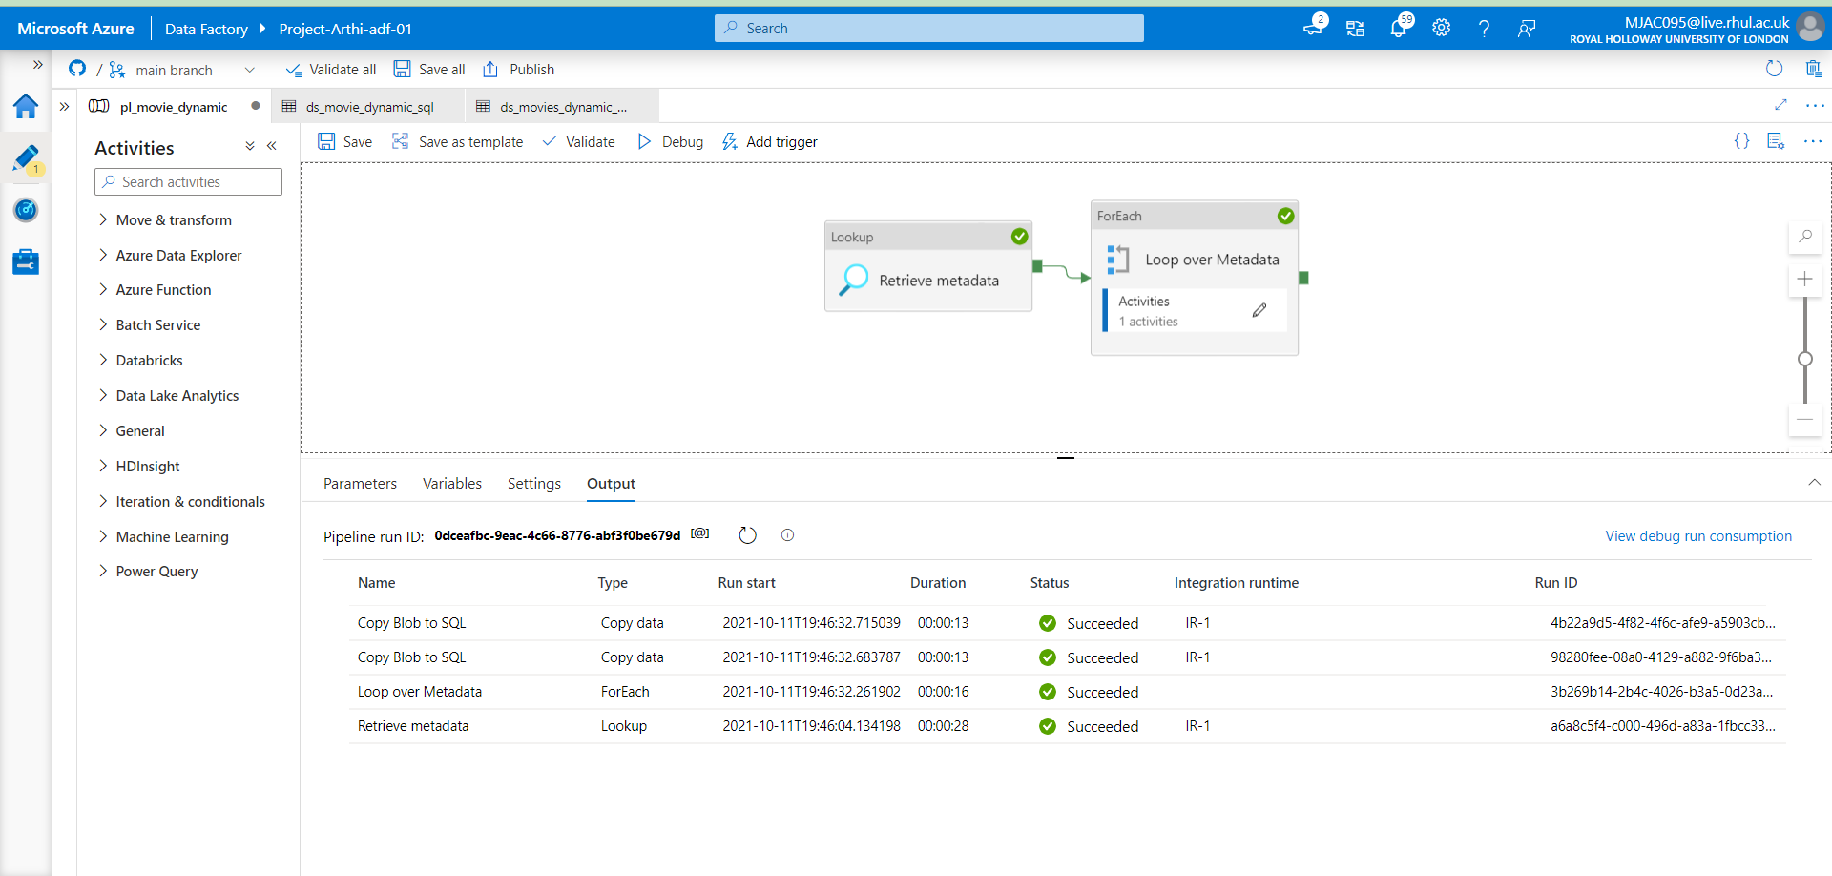

* Output verified: Using SQL Query in the Azure SQL Database, checking the total number of rows in each table and viewing the records.

### **Screenshot 4.5.a:** Output Verification I

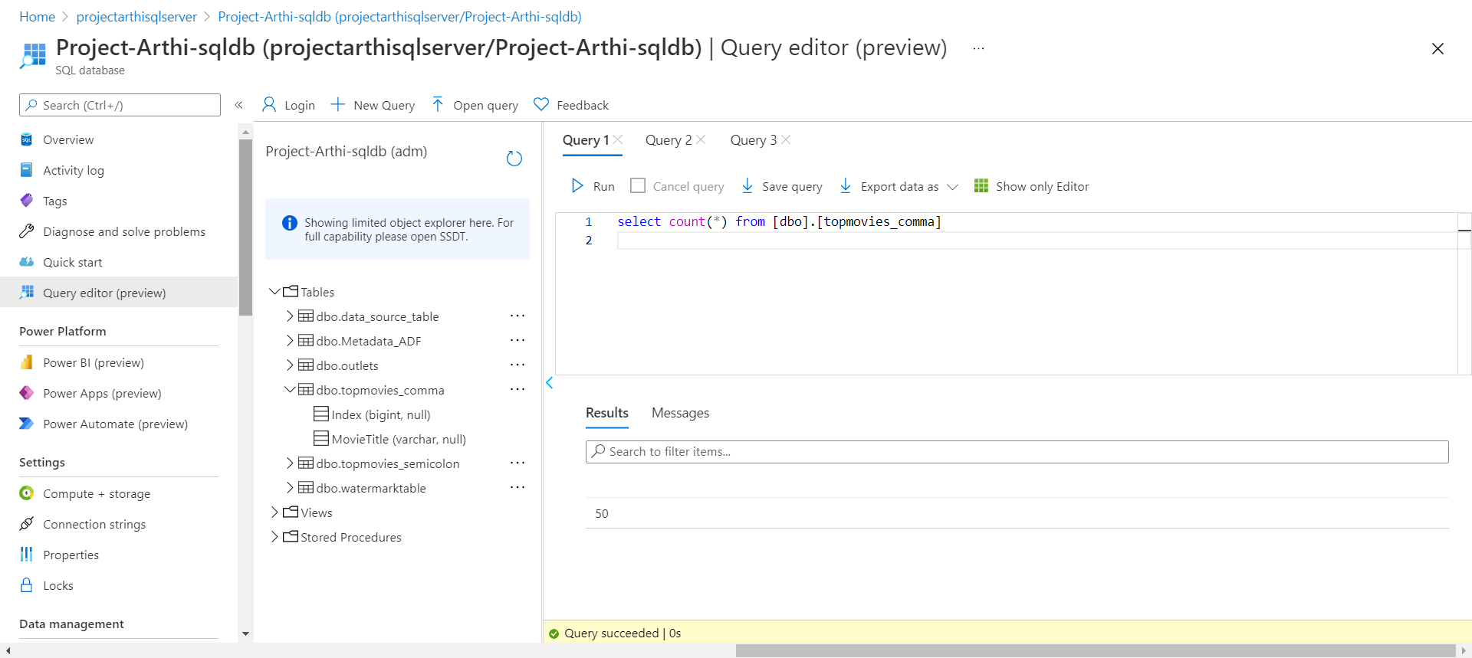

### **Screenshot 4.5.b:** Output Verification II

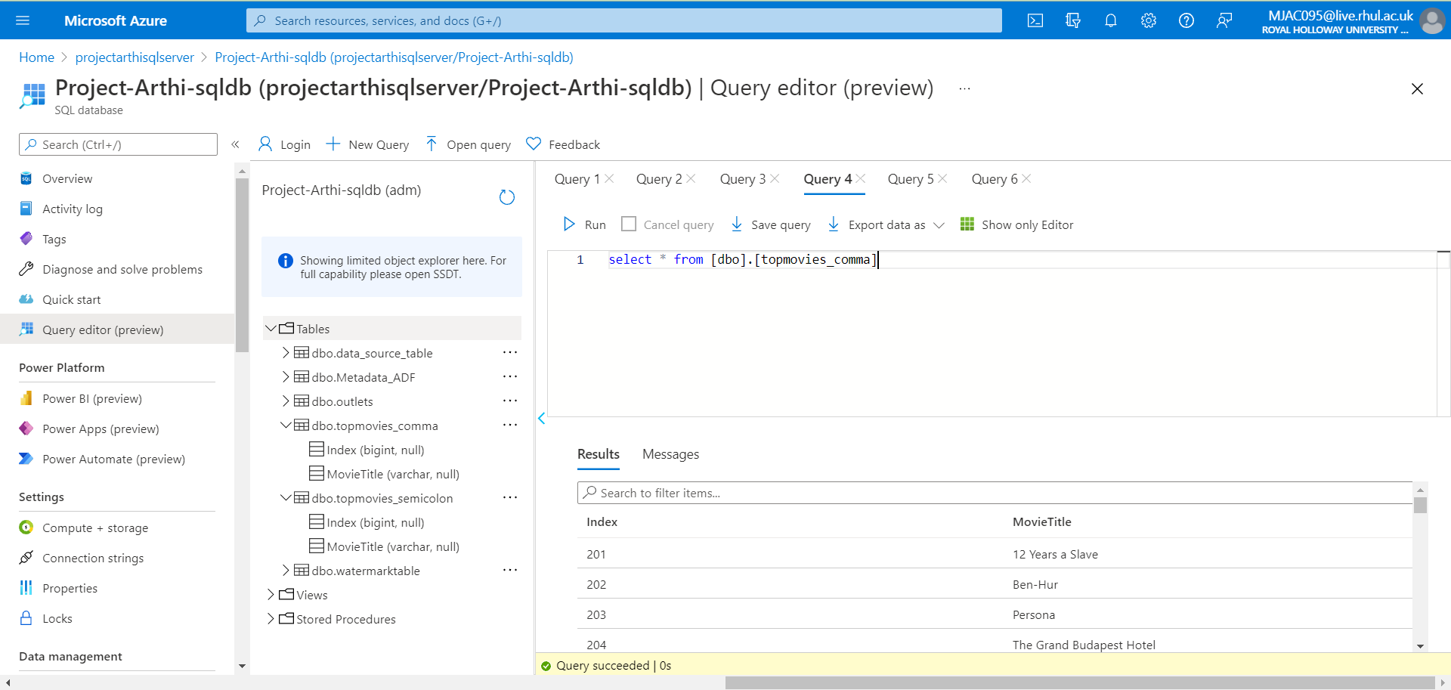

### **Screenshot 4.5.c:** Output Verification III

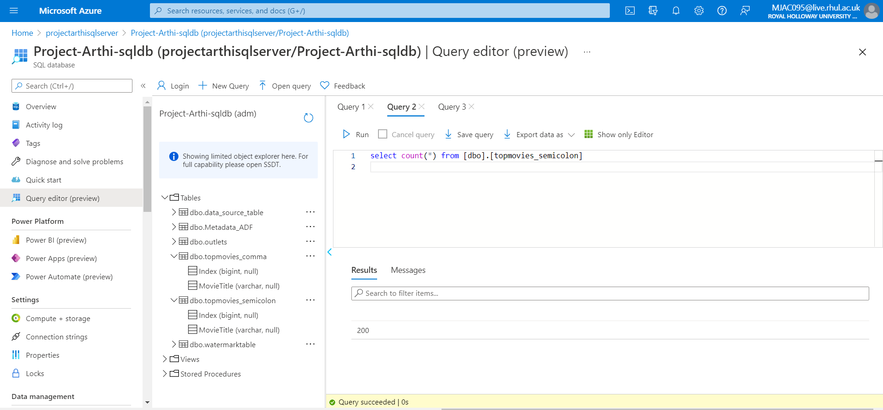

### **Screenshot 4.5.d:** Output Verification IV

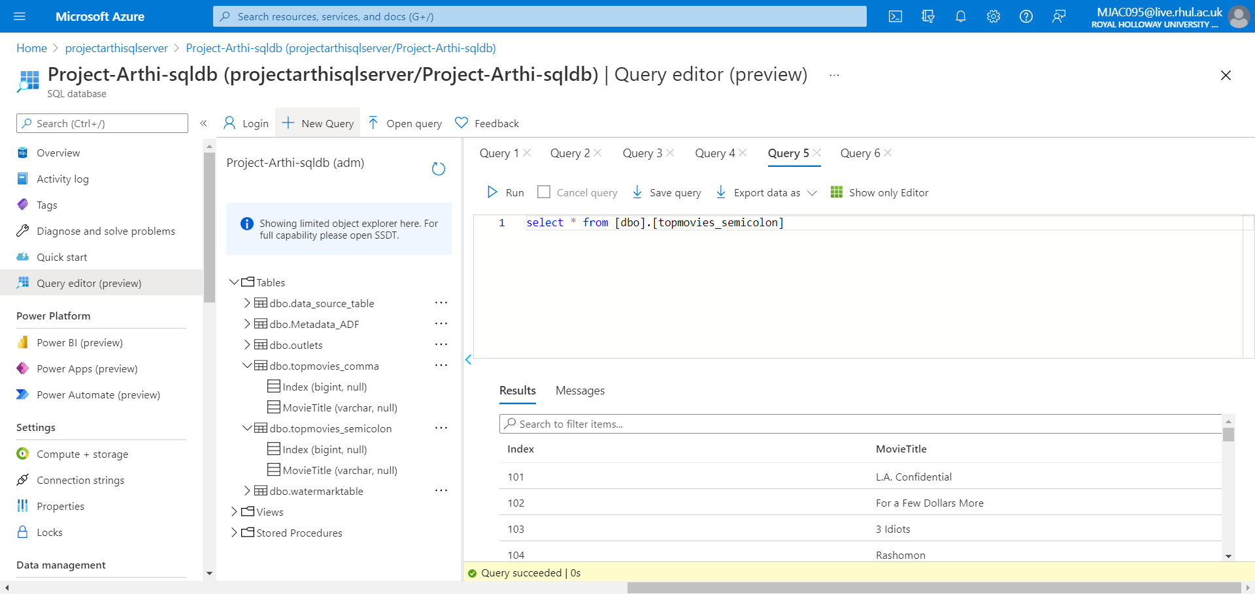

**=================================================================**

Problem Statement 5: **Incrementally load data from Azure SQL Database to Azure Blob storage using the Azure portal**

**=================================================================**

## Solution:

* Created a Resource group, named as: Project-Arthi-rg
* Created a data factory, named as: Project-Arthi-adf-01
* Created a self-hosted integration runtime named as: IR-1, as shown in Screenshot1.1.
* Created 2 tables named **data_source_table** as the data source store, **watermarktable** to store the watermark value and a stored procedure named **usp_write_watermark.**

### Screenshot 5.1.a: Displays table creation in SSMS

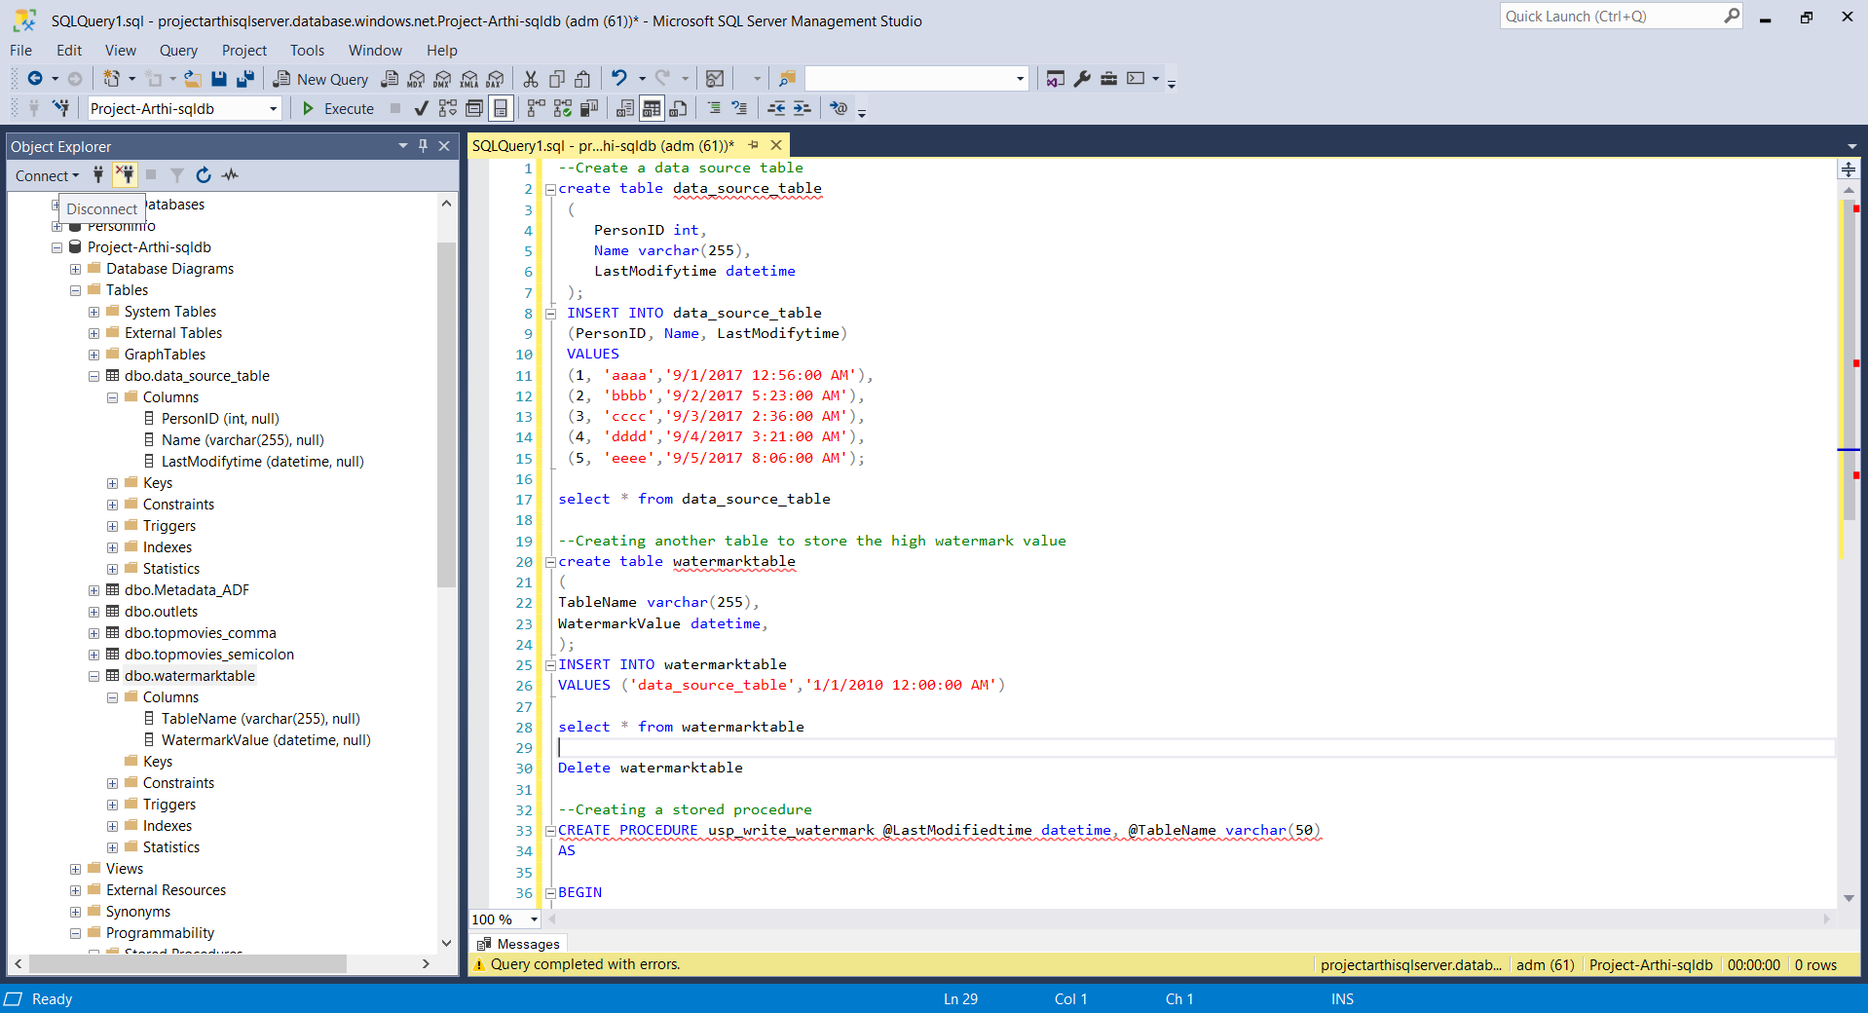

### Screenshot 5.1.b: Displays Table Creation in SSMS:

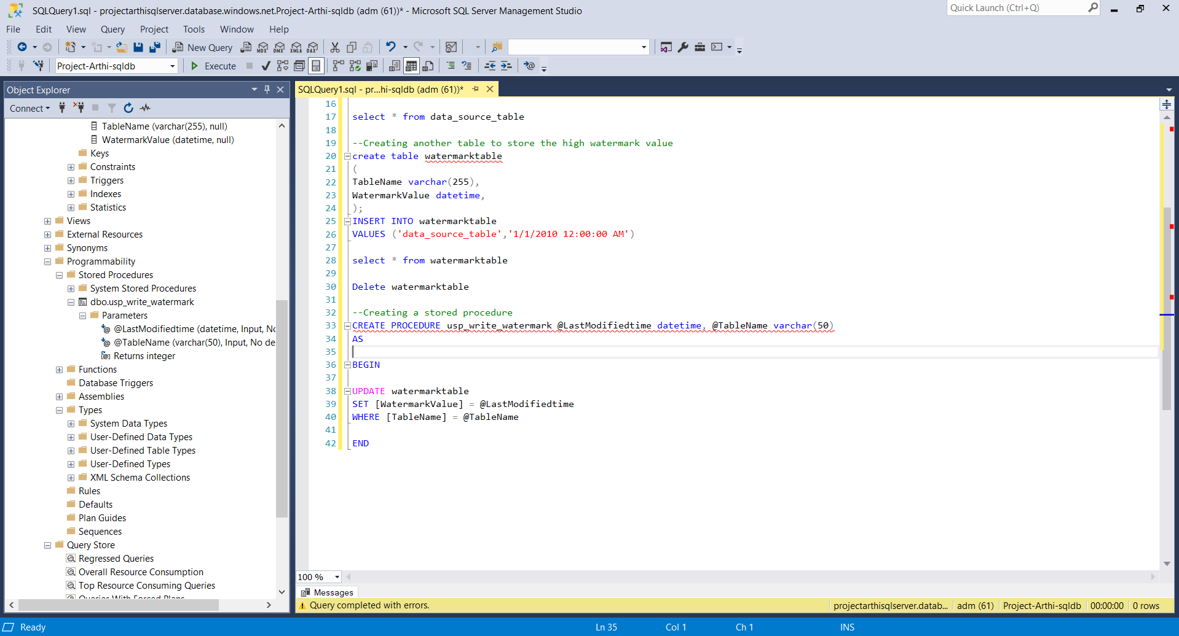

* Created a pipeline named IncrementalCopyPipeline with a Lookup activity **“**LookupOld_wm_act**”** to hold the current watermark data from **watermarktable**. Then set up Source dataset: SourceDataset_q5 with linked service “ls_azsqldb_q5” with data_source_table.

### Screenshot 5.2.a:Displays both pipeline, Old Water Mark LookUp Activity and Watermark Dataset

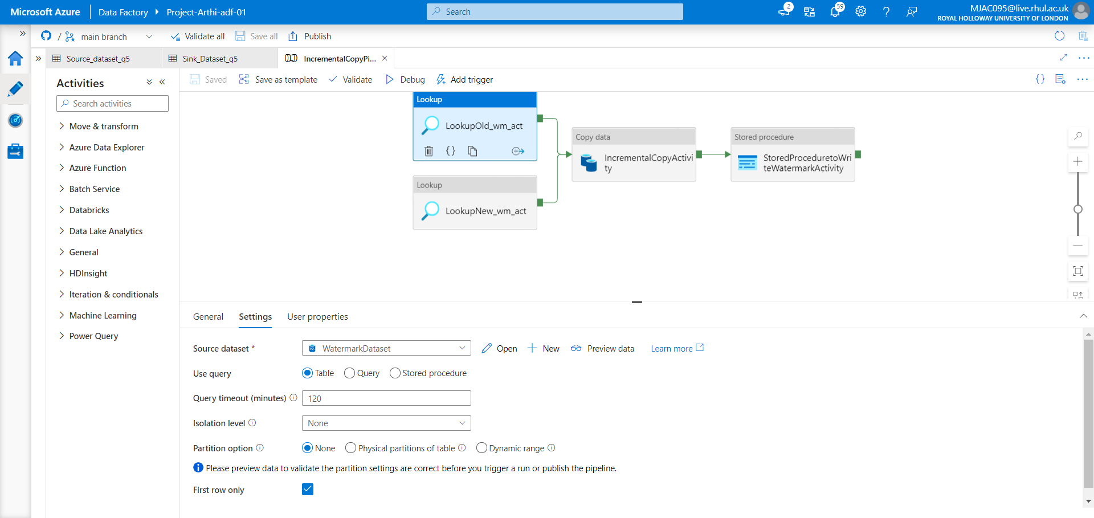

### Screenshot 5.2.b:Displays verifying the Data Source Table in Azure SQL Database

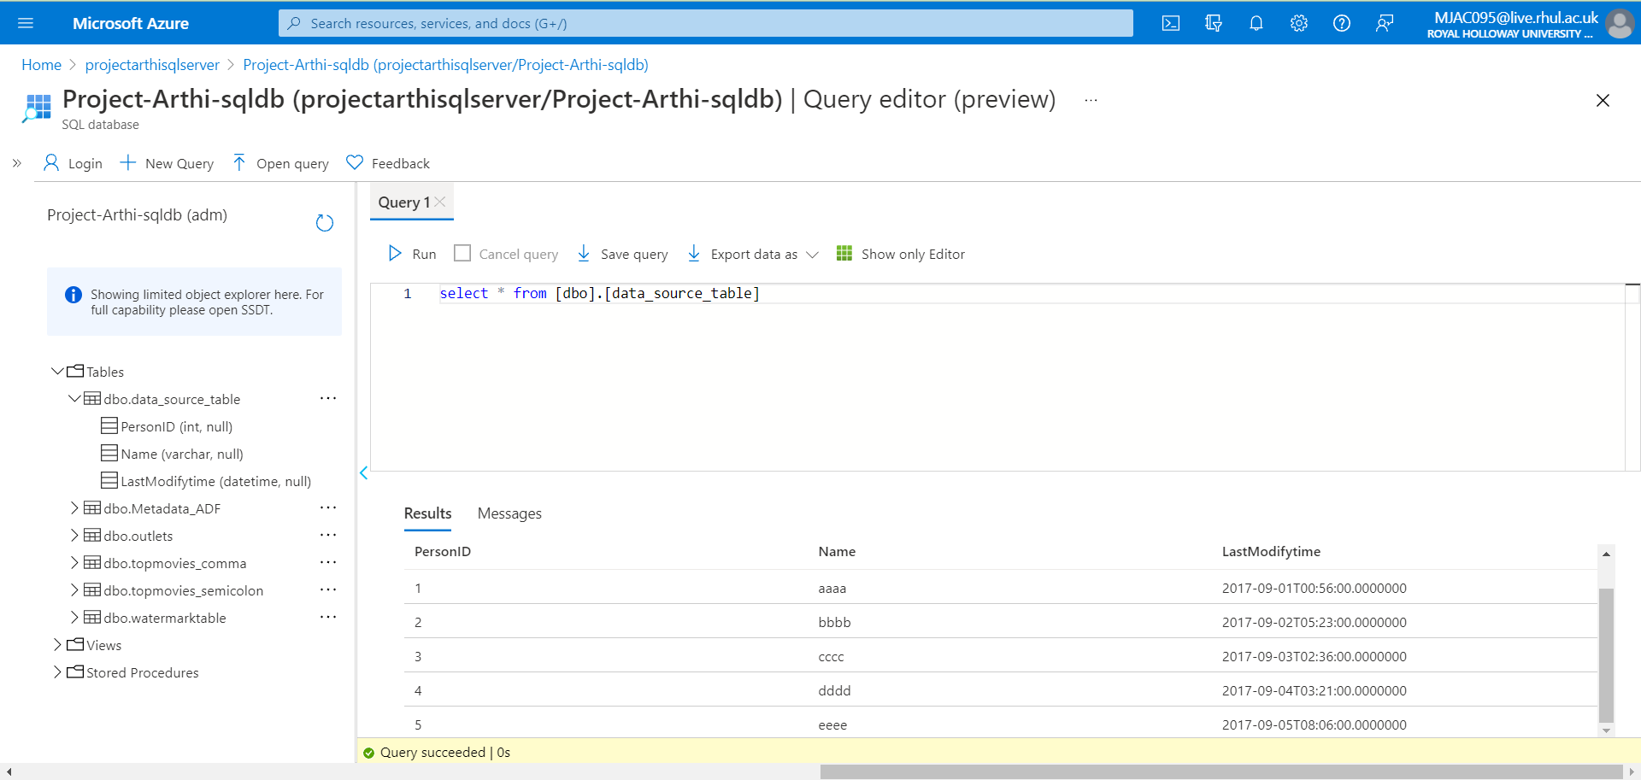

### Screenshot 5.2.c:Displays Linked Services for Watermark Dataset

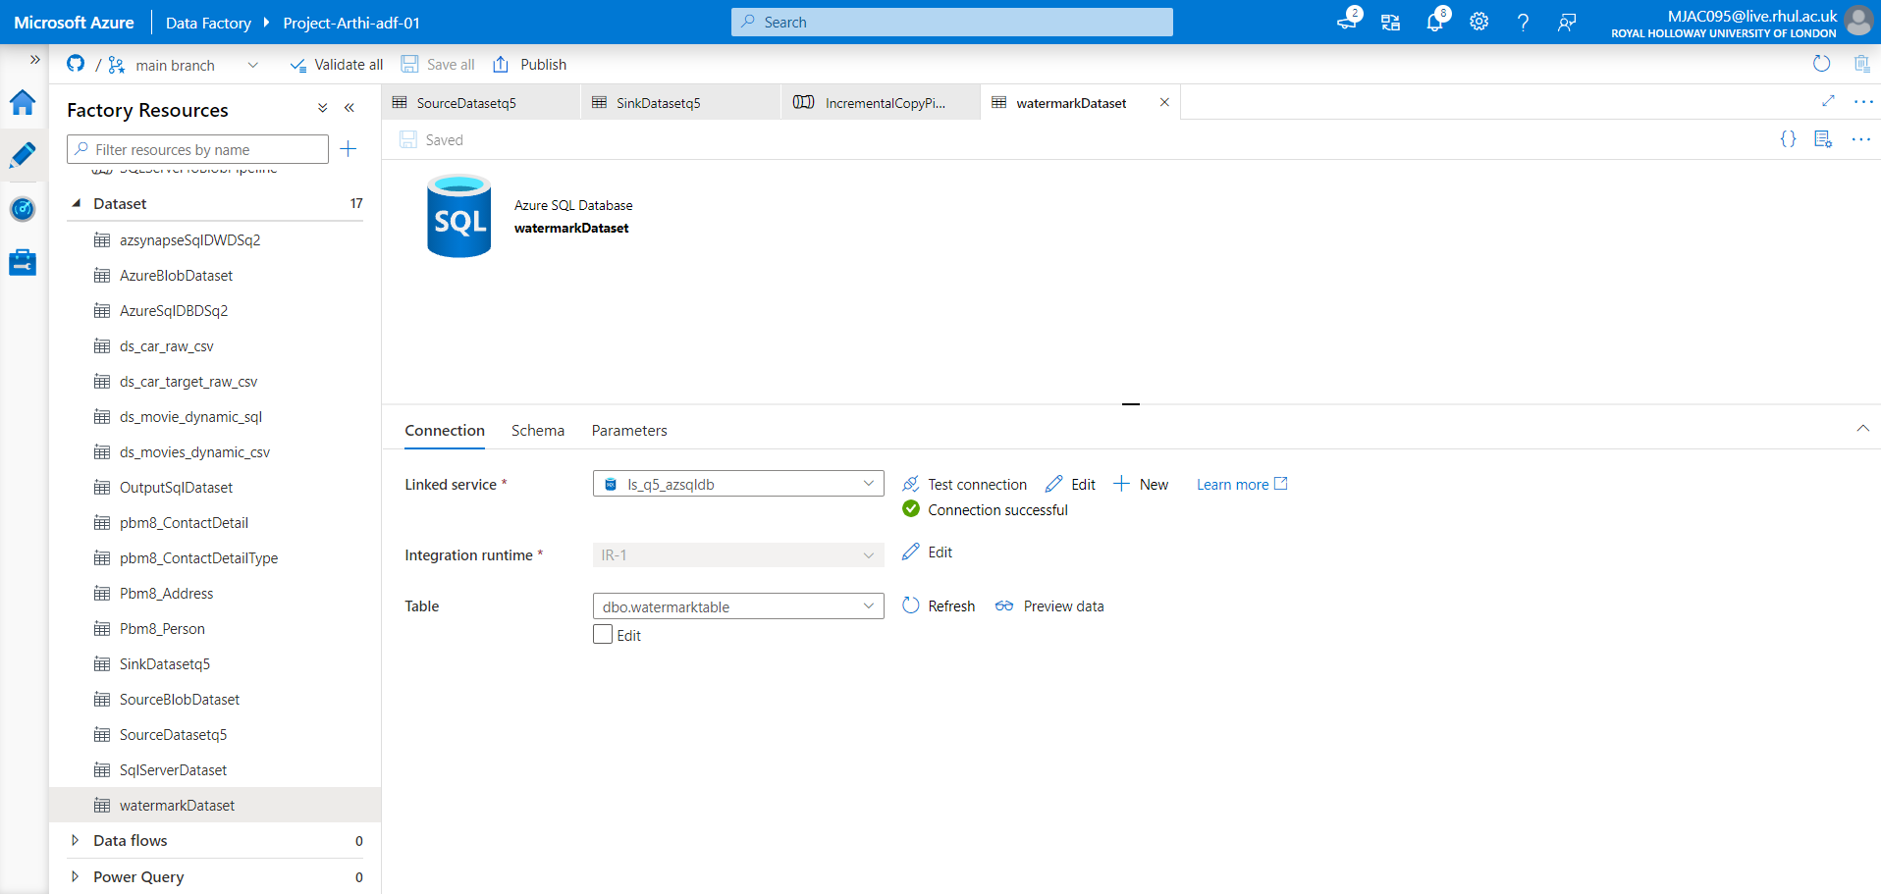

### Screenshot 5.2.d:Displays both pipeline, New Water Mark LookUp Activity with Query

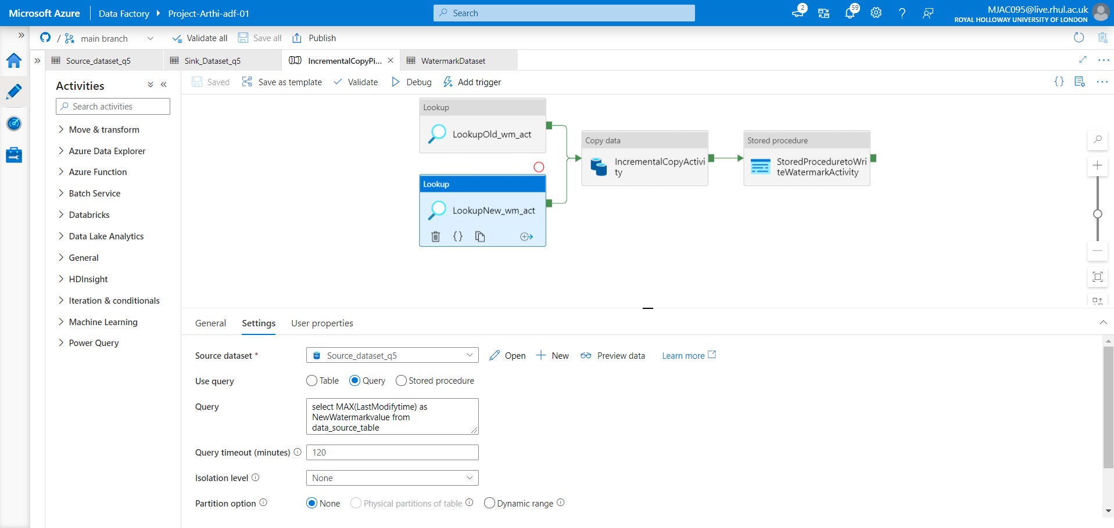

### Query:

select MAX(LastModifytime) as NewWatermarkvalue from data_source_table

### Screenshot 5.2.e:Displays Incremental Copy Activity and Source Dataset Details

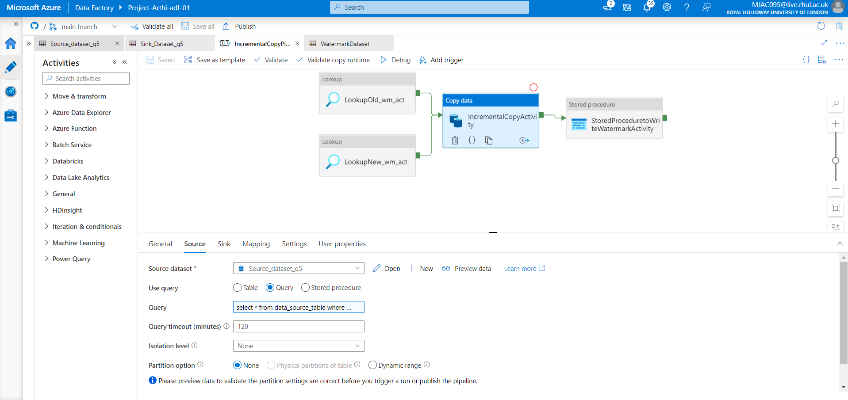

### Query:

select * from data_source_table where LastModifytime > '@{activity('LookupOldWaterMarkActivity').output.firstRow.WatermarkValue}' and LastModifytime <= '@{activity('LookupNewWaterMarkActivity').output.firstRow.NewWatermarkvalue}'

### Screenshot 5.2.f:Displays Sink Dataset Details

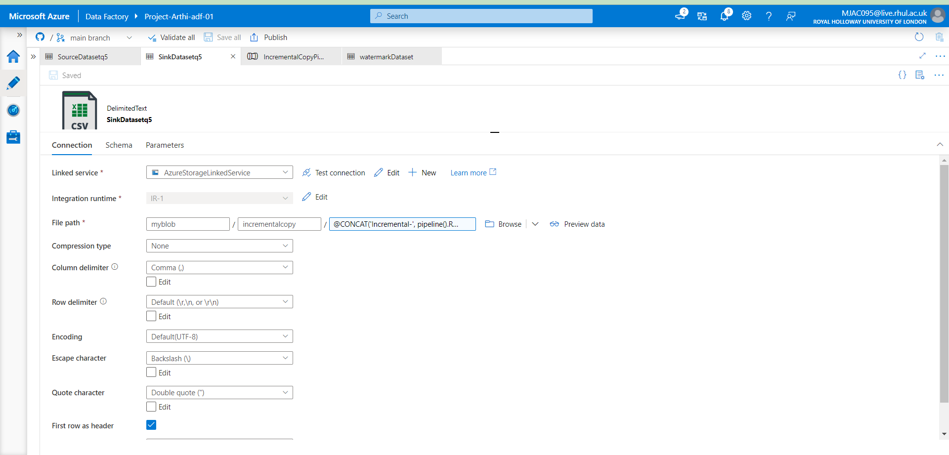

* Azure Data Factory automatically creates the output folder **incrementalcopy** if it does not exist. In the Screenshot, we have browsed the **File path** to navigate to a folder in a **blob container**. In the File path field, add the dynamic content :

@CONCAT ('Incremental-', pipeline (). RunId, '.txt')

### Screenshot 5.3.a: Pipeline Debug Details

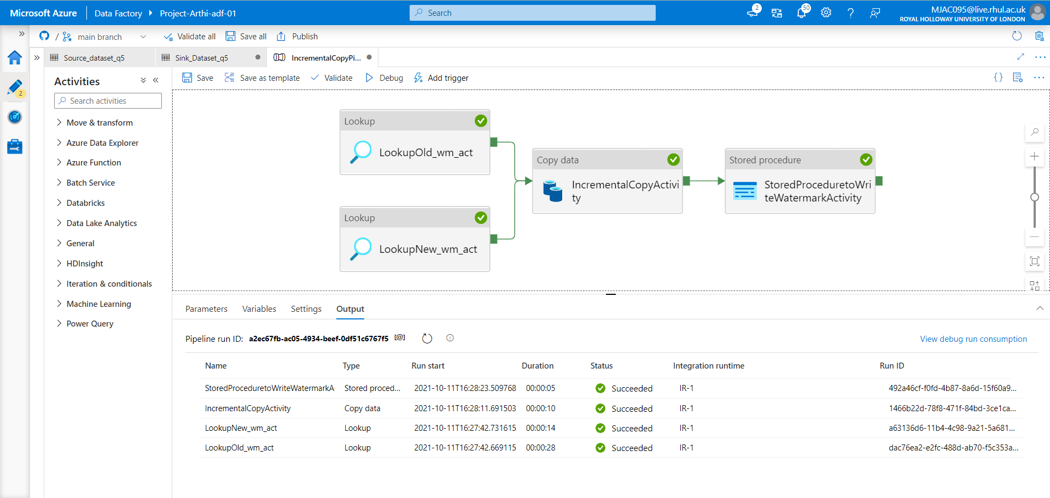

### Screenshot 5.3.b: Pipeline Activity Details

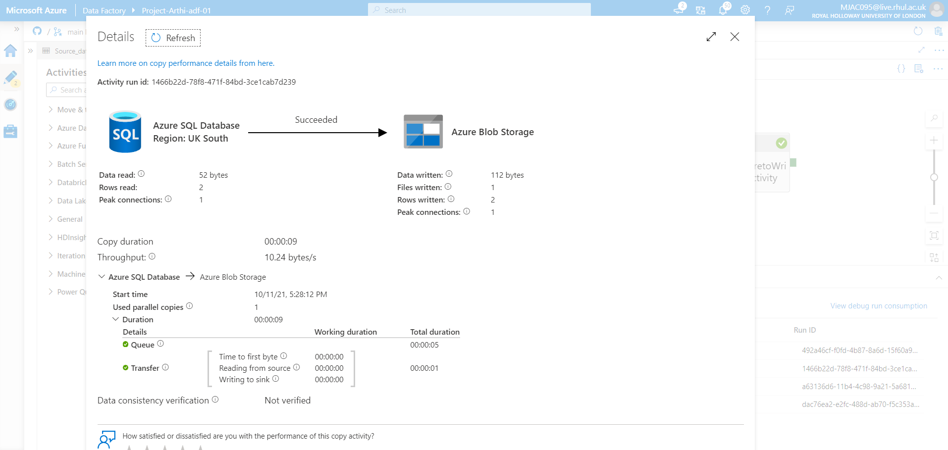

* Added trigger by clicking on trigger now

### Screenshot 5.3.c: Pipeline Debug Detail II

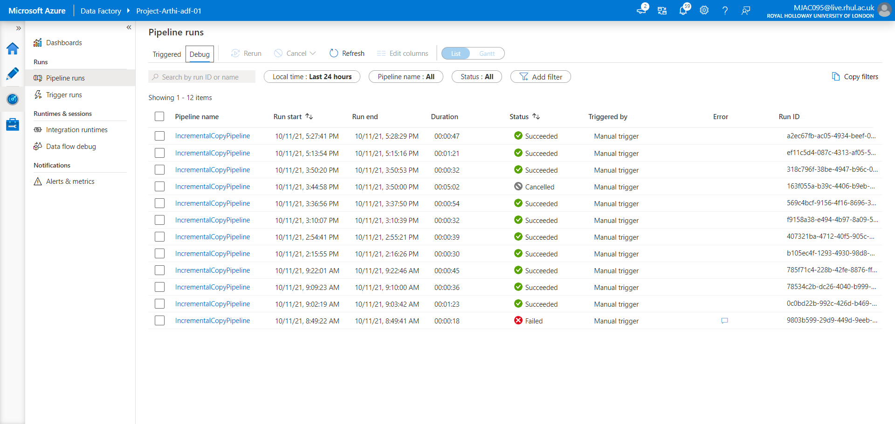

### Screenshot 5.3.d: Pipeline Trigger Details

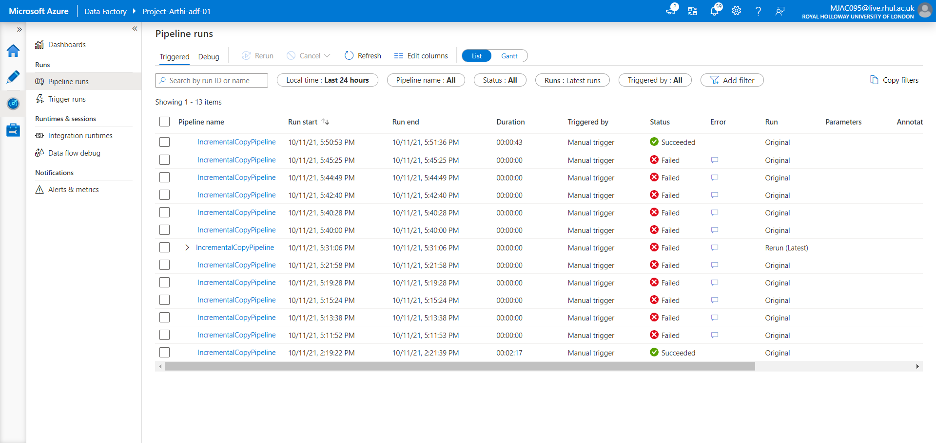

* Output verified: Table values in Azure SQL database copied to Text File in Azure blob storage
* When the copy activity performed for first time, text file 5 rows copied into text file as first row as header and next 5 records as 5 rows.
* New watermark is captured from the table using the query.
* New values 2 records are inserted into to the table
* When we triggered, records are copied into new text file, therefore updated 2 records are created in the table with index value 6,7.
* Again, New watermark is captured from the table using the query.

### Screenshot 5.4: New records insertion in Data Source Table

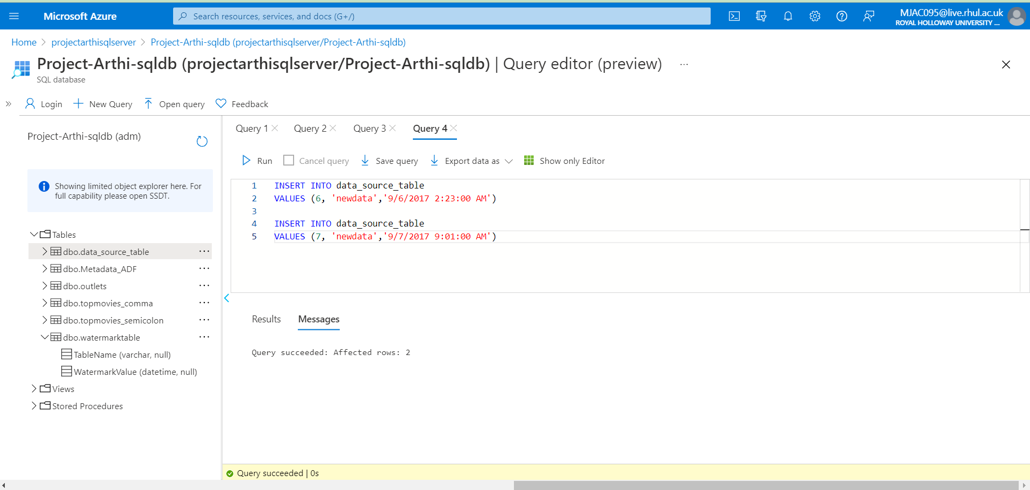

### Screenshot 5.5: Output Verification: Files generated after every run

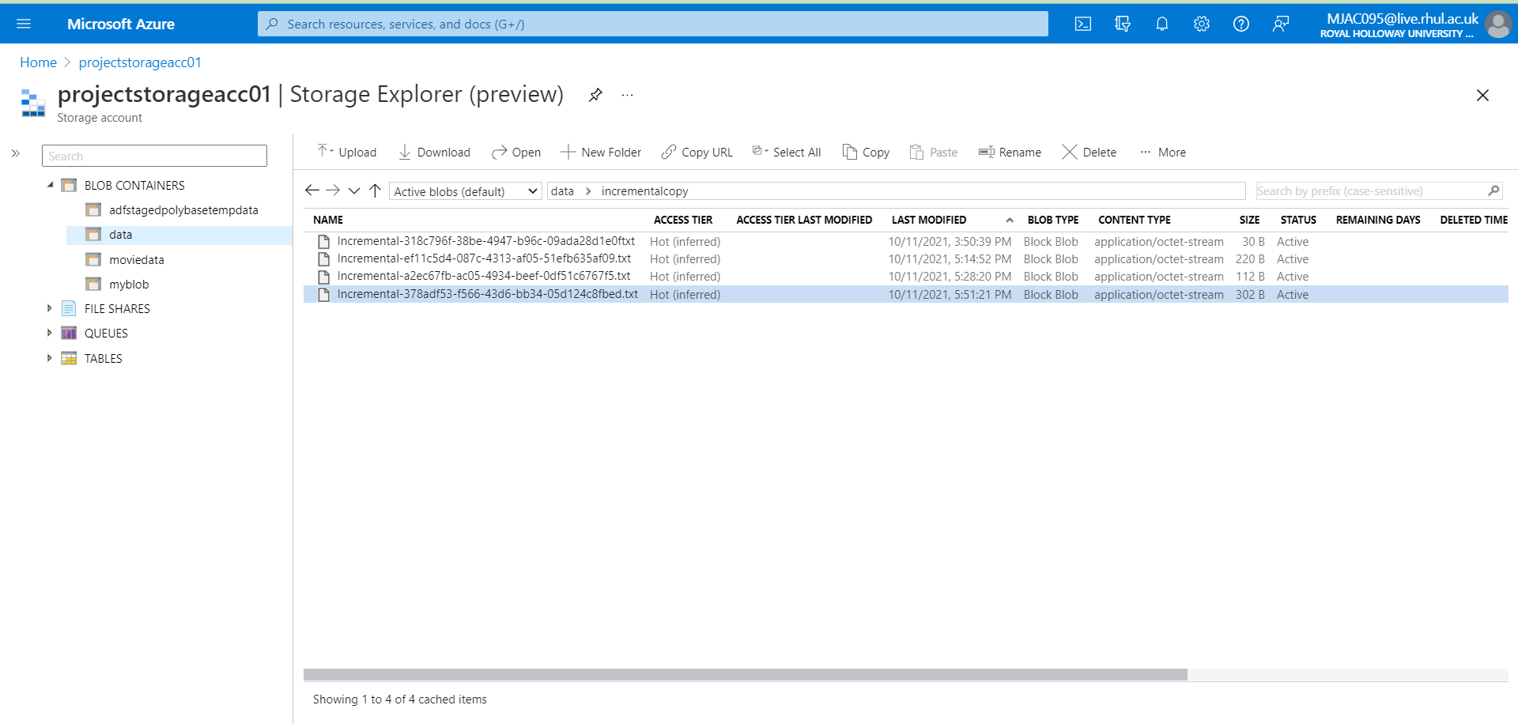

Files: attached queries and output text files for this Problem in Solution5 Folder.

**=================================================================**

Problem Statement 6: **Design a Relational Database Model for the below scenario in Azure SQL Database=================================================================**

## Solution :

* Created a Azure SQL Database named as: **universitydb** containing 4 Tables namely

**dbo.Person, dbo.Student,dbo.Course, dbo.Credit**

* Created tables and relationship among them as given in the problem
* Created database and populated the table using insert query in each table using random values

### Screenshot 6.1: Creating DB in Azure SQL Database

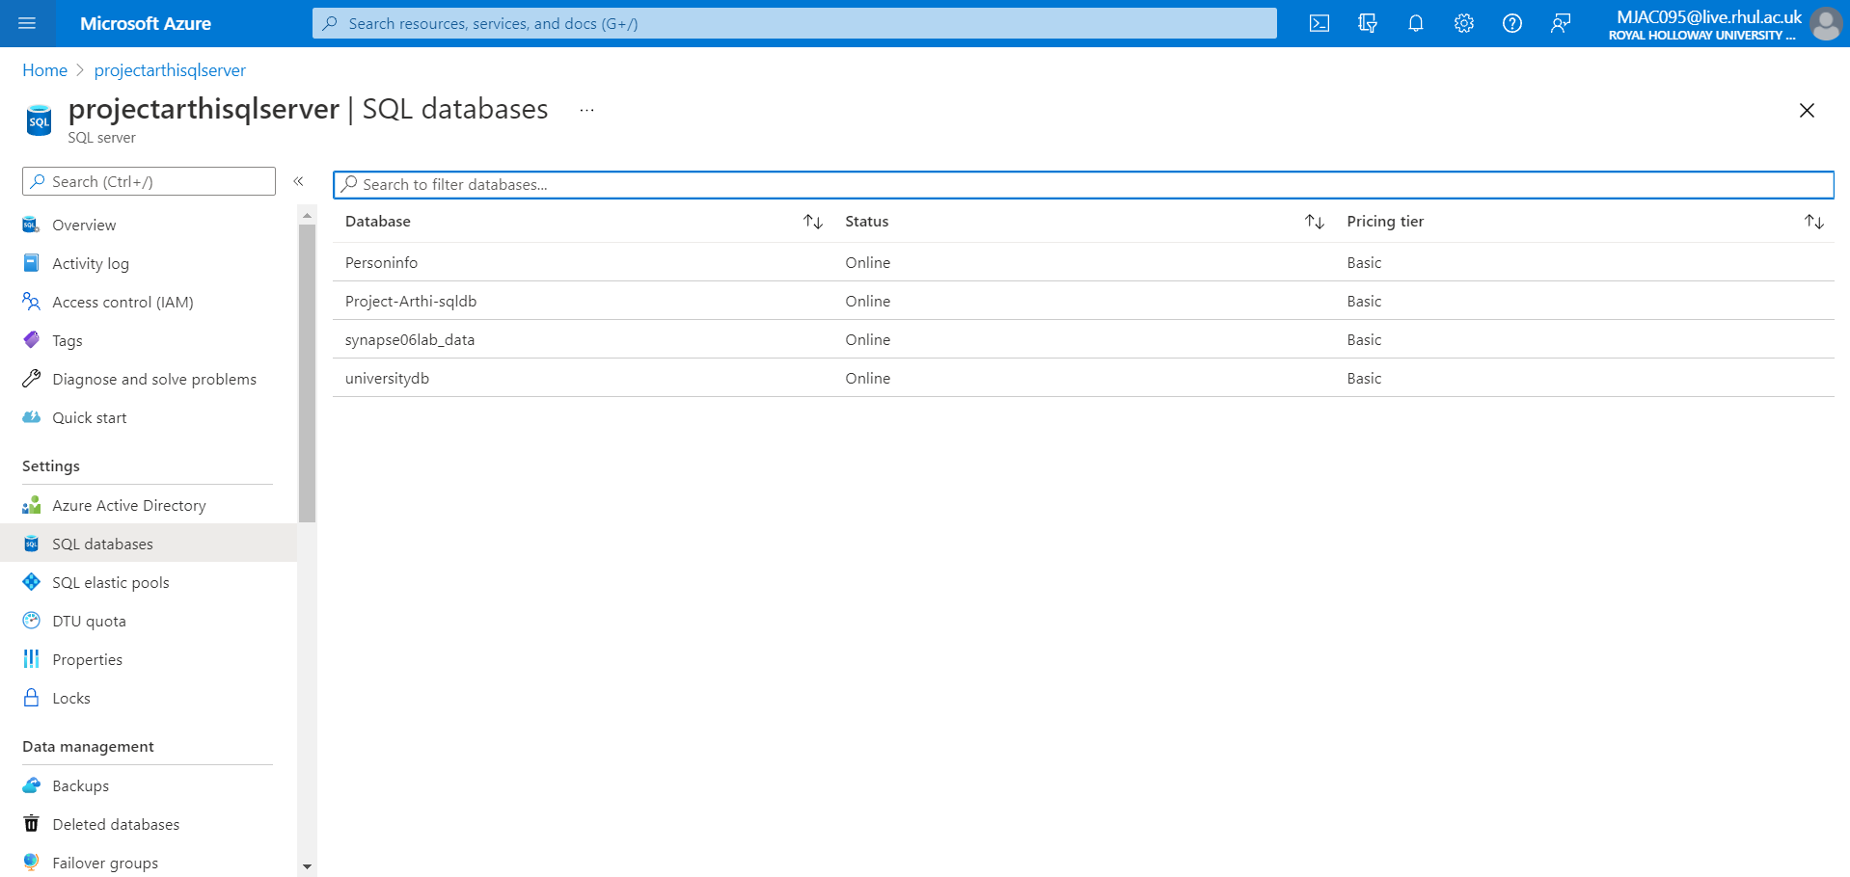

### Screenshot 6.2.a: Creating Person Table

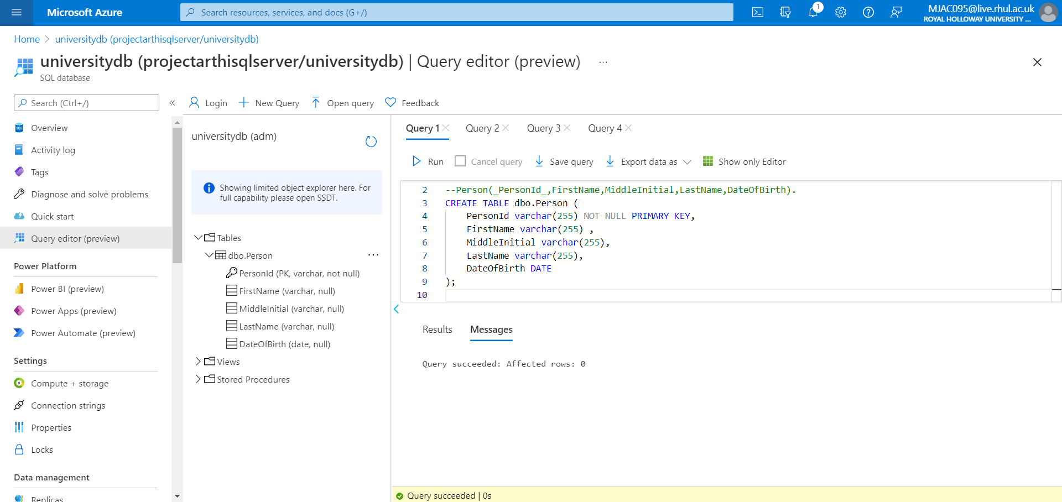

### Screenshot 6.2.b: Creating Course Table

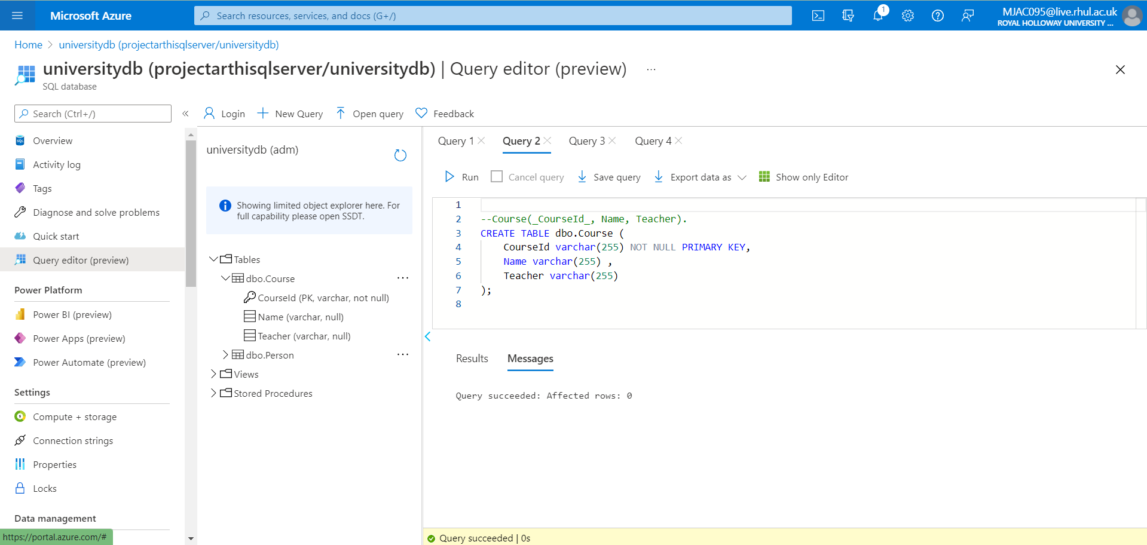

### Screenshot 6.2.c: Creating Student Table

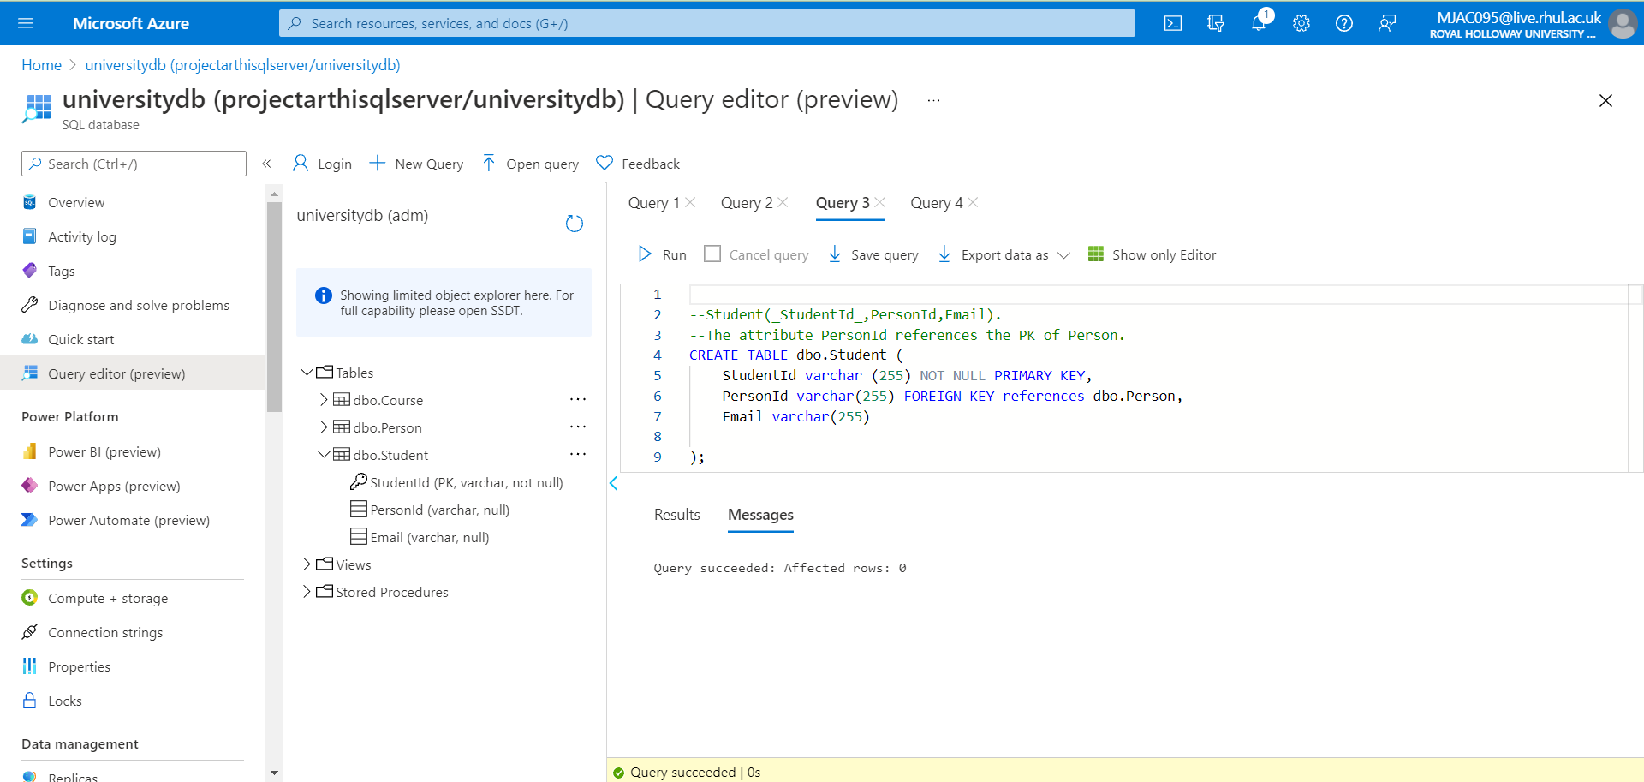

### Screenshot 6.2.d: Creating Credit Table

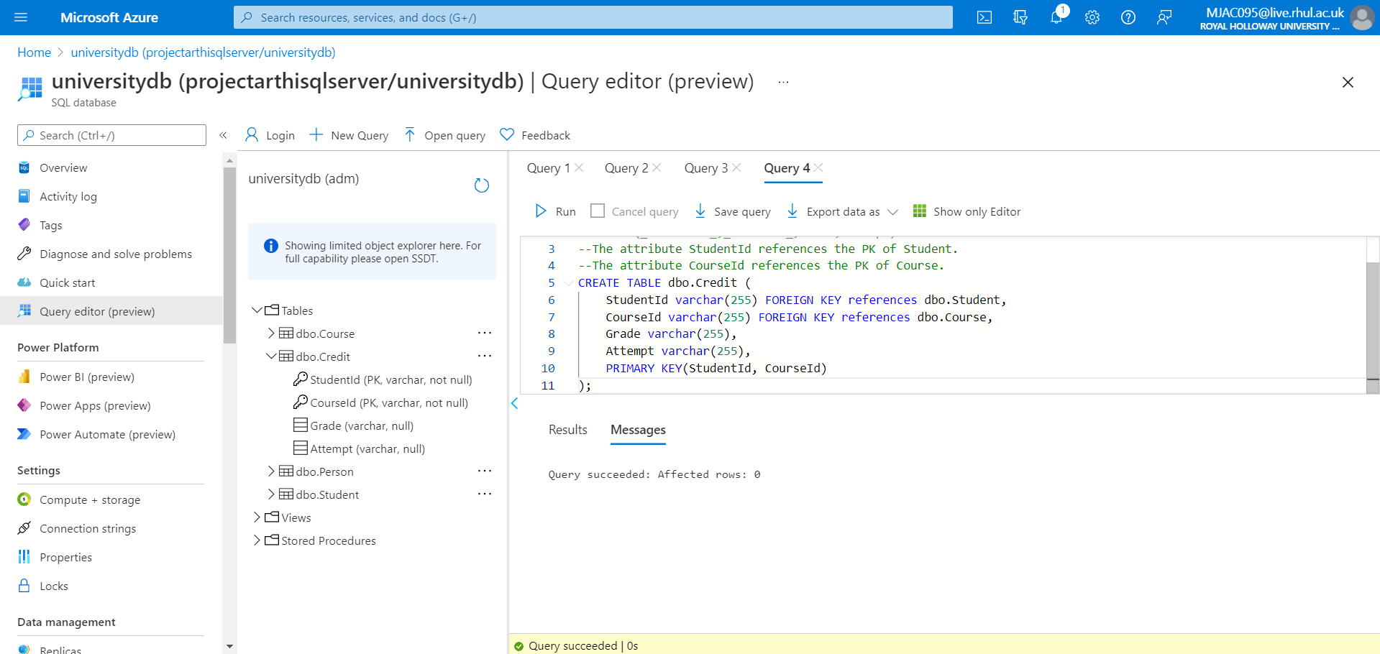

### Screenshot 6.3.a: Populating Person Table

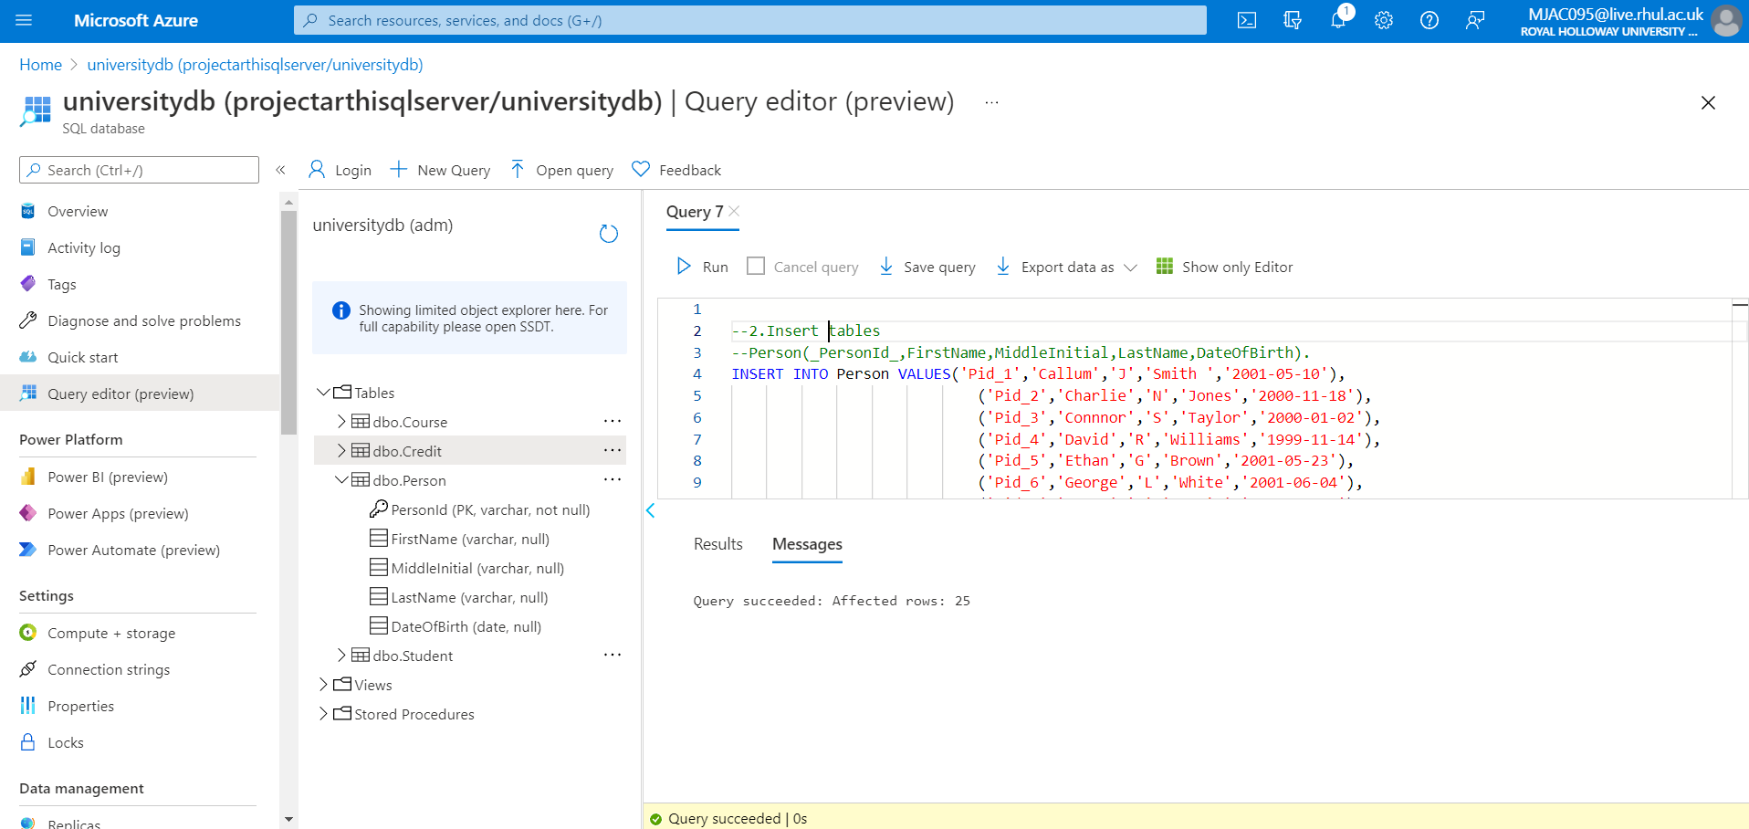

### Screenshot 6.3.b: Populating Course Table

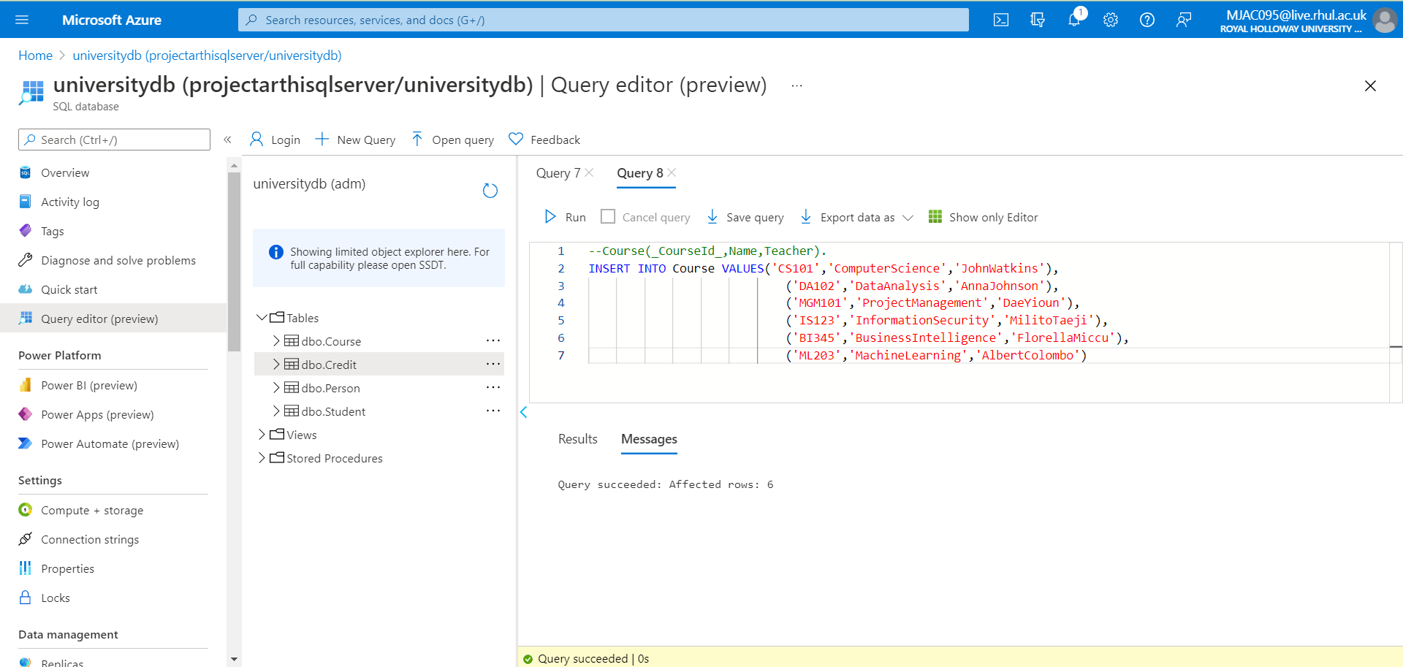

### Screenshot 6.3.c: Populating Student Table

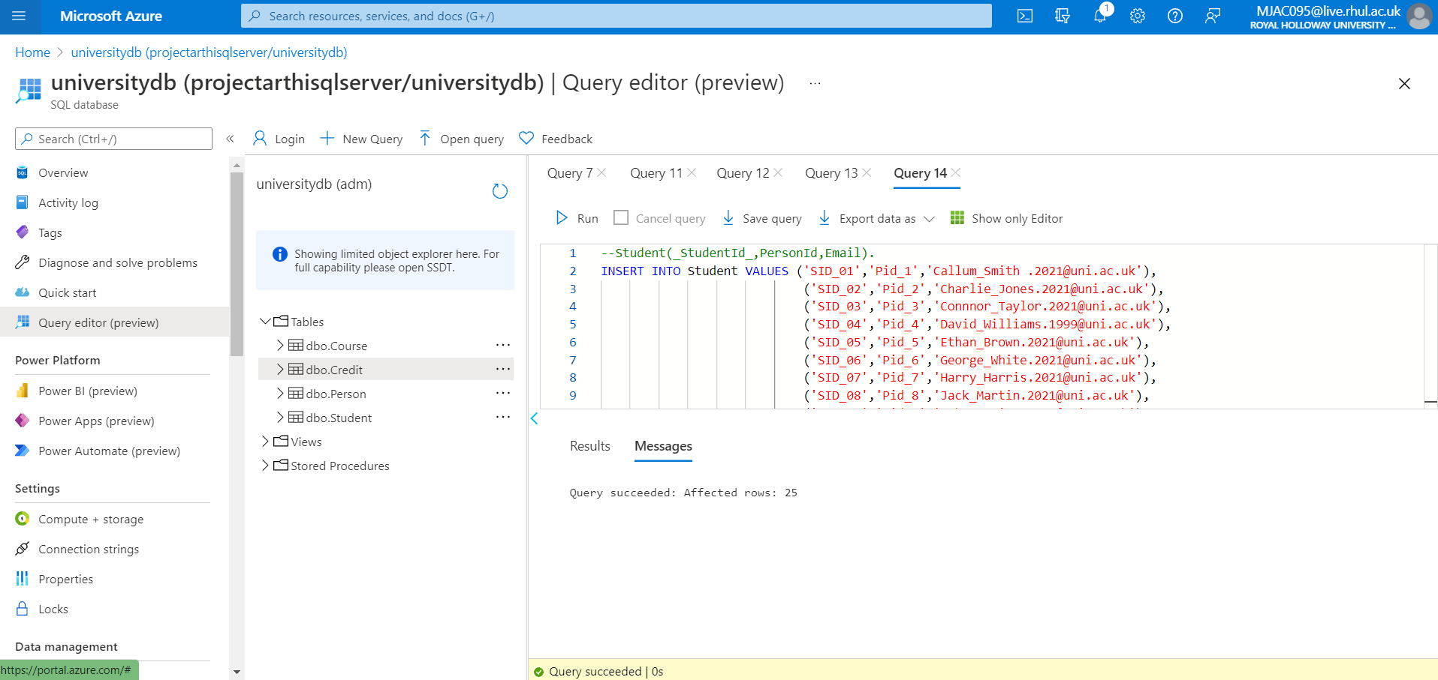

### Screenshot 6.3.d: Populating Credit Table

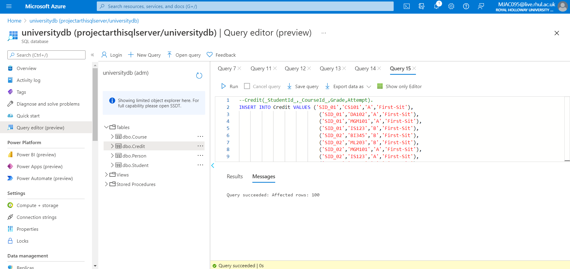

### Screenshot 6.4: Output Verification: Query to extract the student details

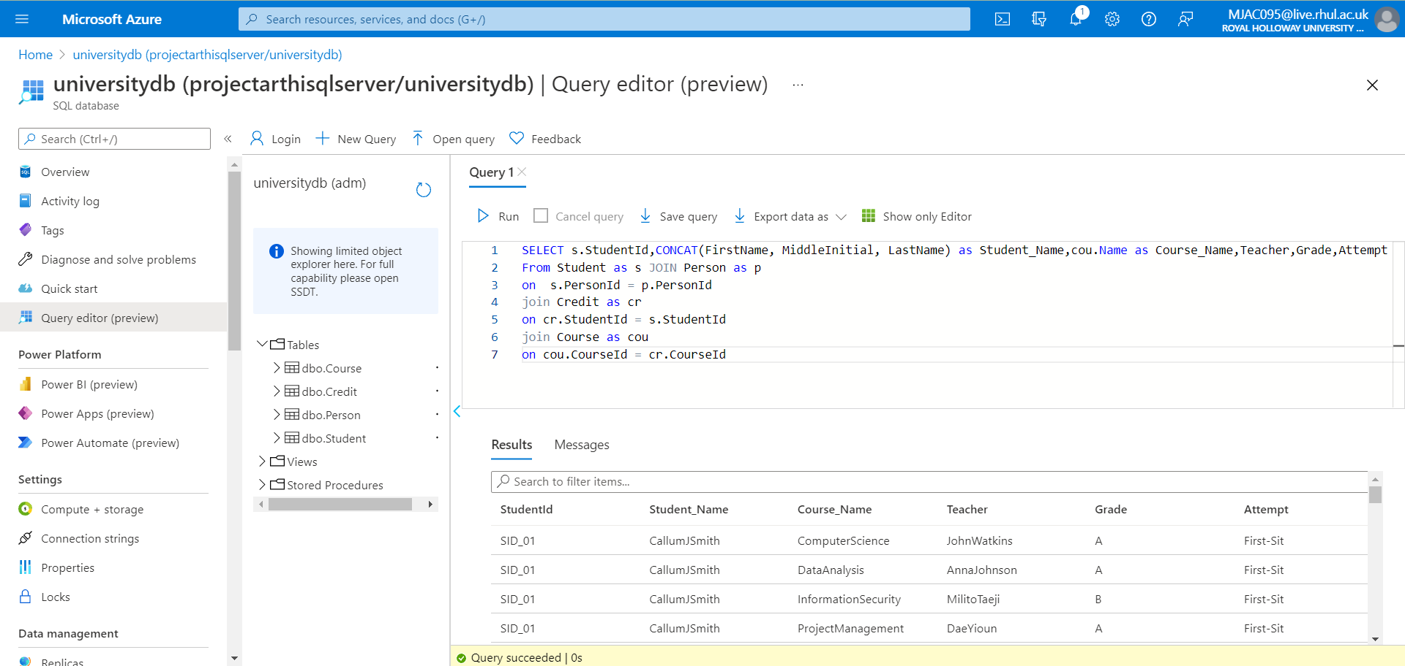

Files: attached create table, insert values, and extracting queries sql file of this Problem is in Solution6 Folder.

**=================================================================**

Problem Statement 7: **Design a Relational Database Model for the below scenario in Azure SQL Database**

**=================================================================**

## Solution :

* Created an Azure SQL Database named as: **Personinfo** containing 4 Tables namely

**dbo.Person, dbo.Address,dbo.ContactDetail, dbo.ContactDetailType**

* Created tables and relationship among them as given in the problem
* Created database and populated the table using insert query in each table using random values.

### Screenshot 7.1: Creating DB in Azure SQL Database



### Screenshot 7.1.a: Creating Person Table

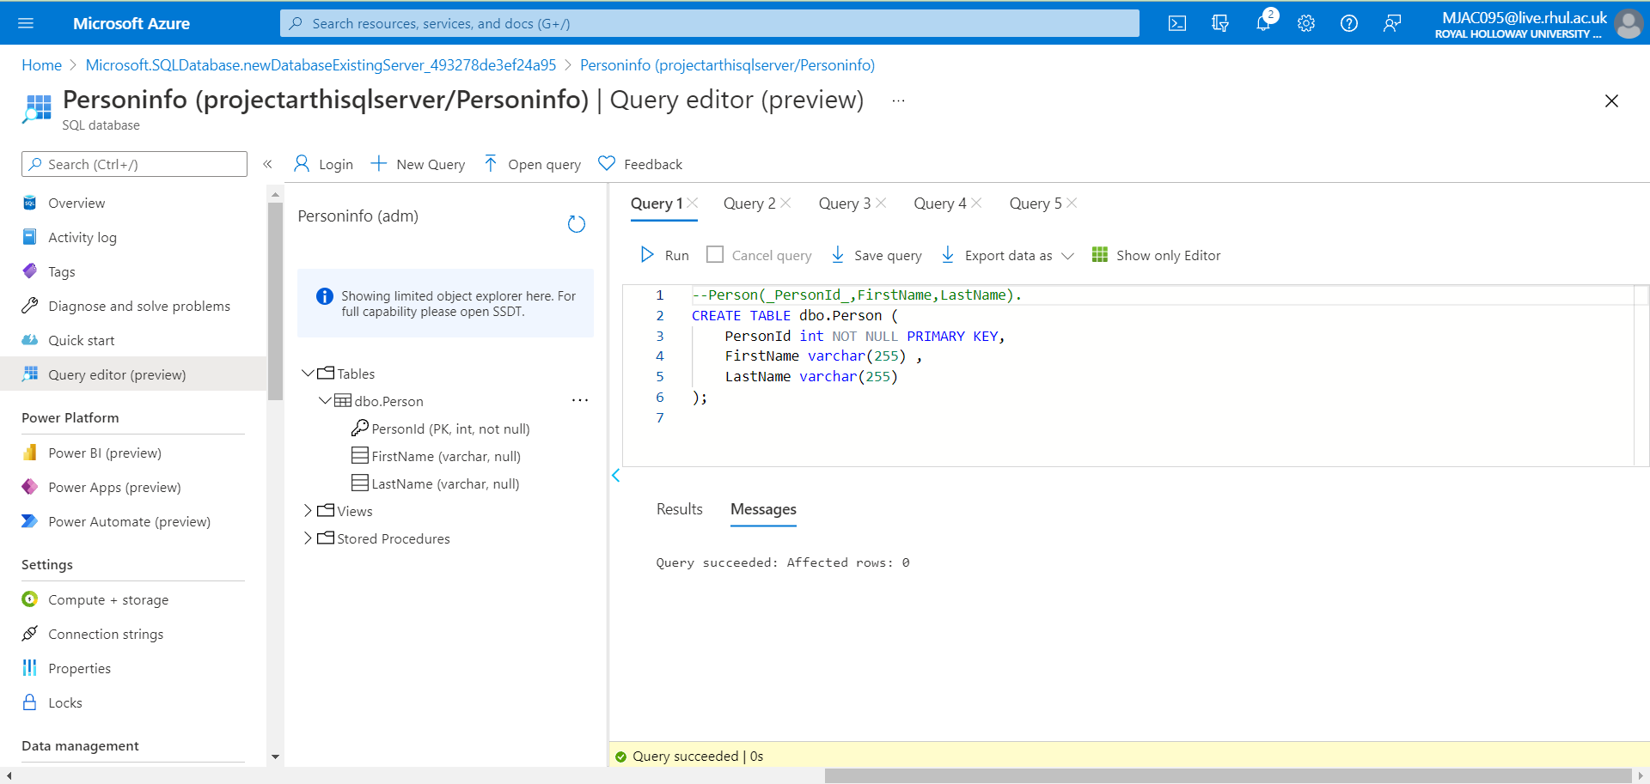

### Screenshot 7.1.b: Creating ContactDetailType Table

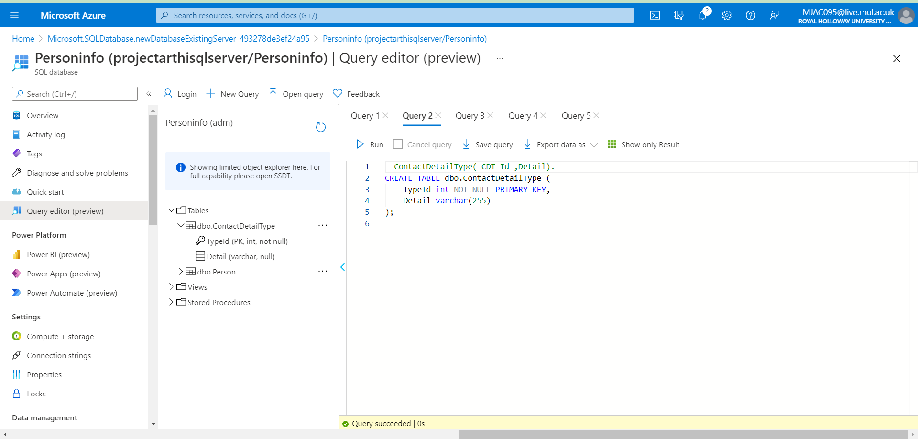

### Screenshot 7.1.c: Creating Address Table

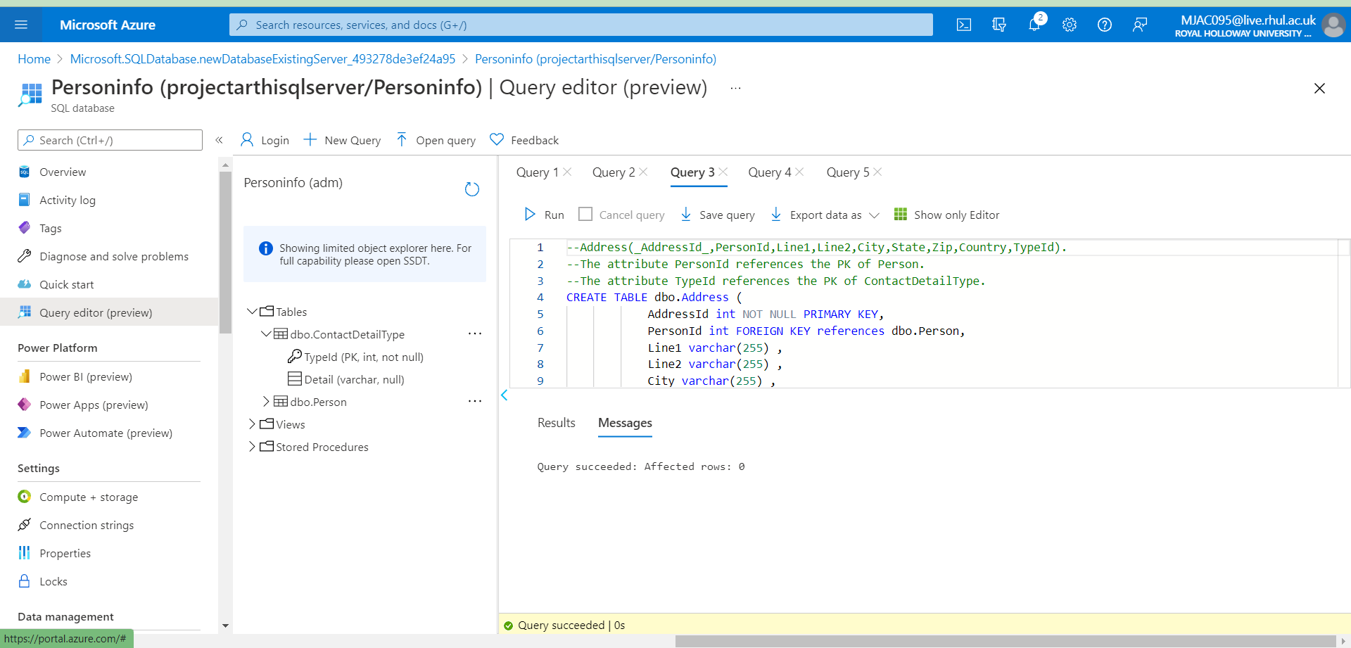

### Screenshot 7.1.d: Creating ContactDetail Table

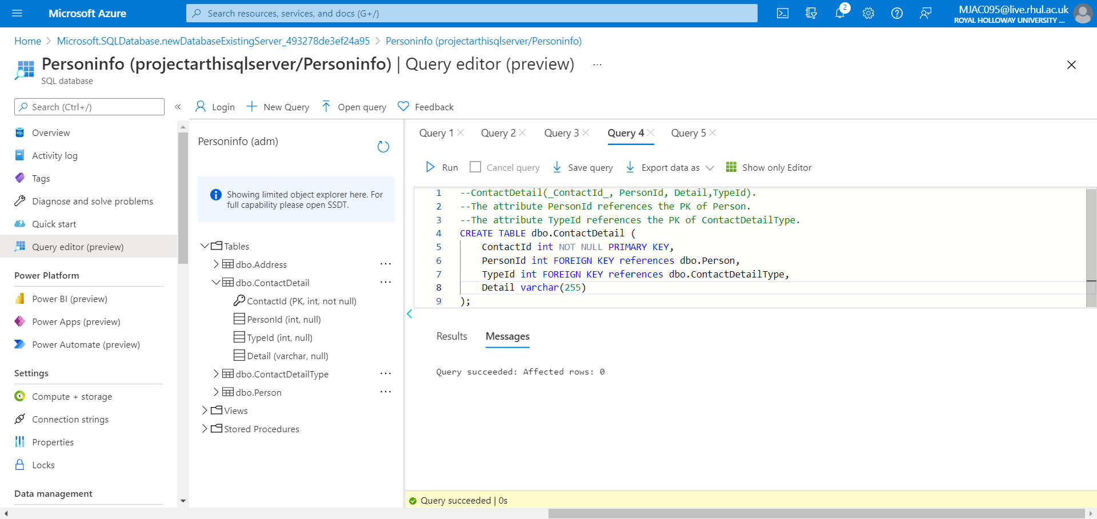

### Screenshot 7.2.a: Populating Person, ContactDetailType, Address Table

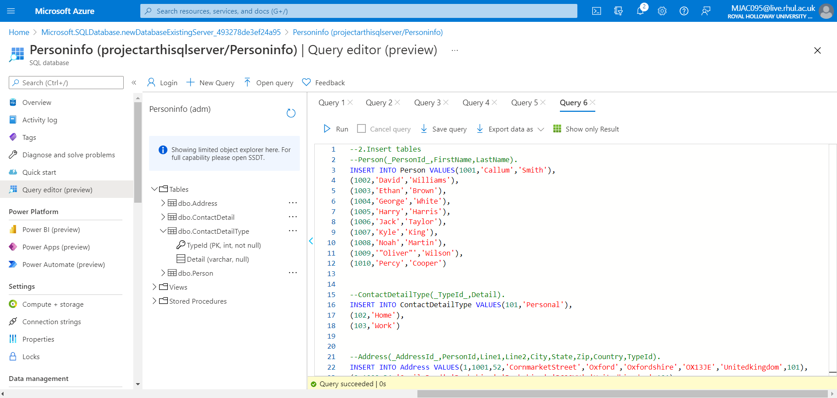

### Screenshot 7.2.b: Populating Table ContactDetail

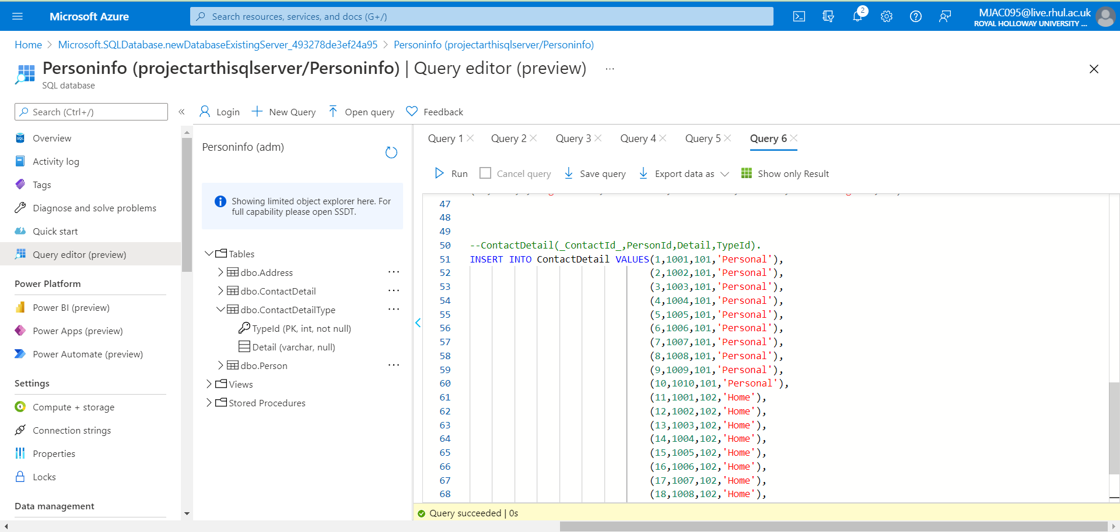

### Screenshot 7.3: Output Verification: Query to extract the Person details

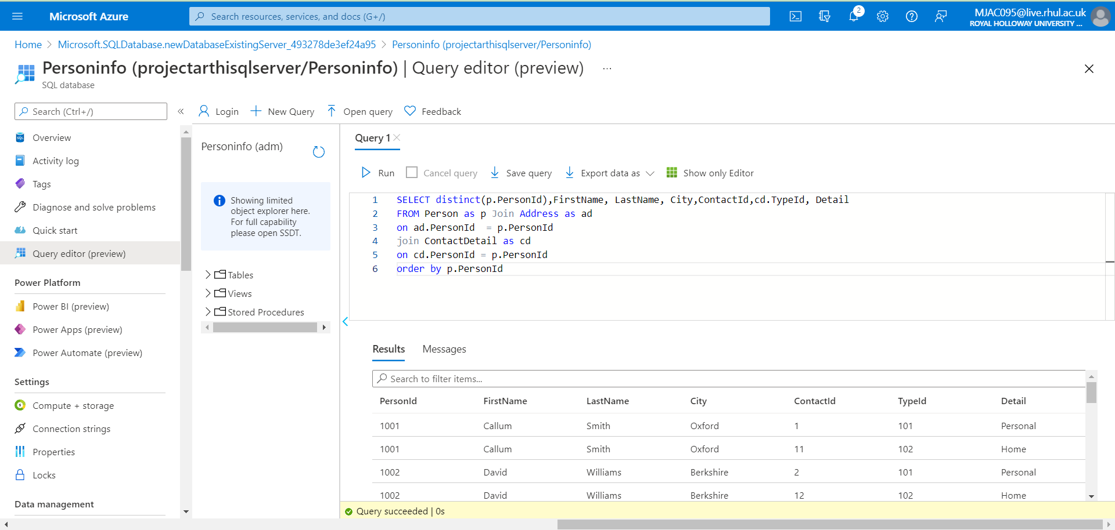

Files: attached create table, insert values, and extracting queries sql file with this Project in Solution7 Folder.

**=================================================================**

Problem Statement 8: **Design a Non-Relational Database Model equivalent for a Relational Model**

**=================================================================**

## Solution :

* Created an Azure SQL Database named as: **Personinfo** containing 4 Tables namely

**dbo.Person, dbo.Address,dbo.ContactDetail, dbo.ContactDetailType**

* Created tables and relationship among them as given in the problem
* Created database and populated the table using insert query in each table using random values
* Created a dataset for each table in Azure Data factory to have table in JSON schema

### Screenshot 8.1.a: Datasets for PersonInfoDb

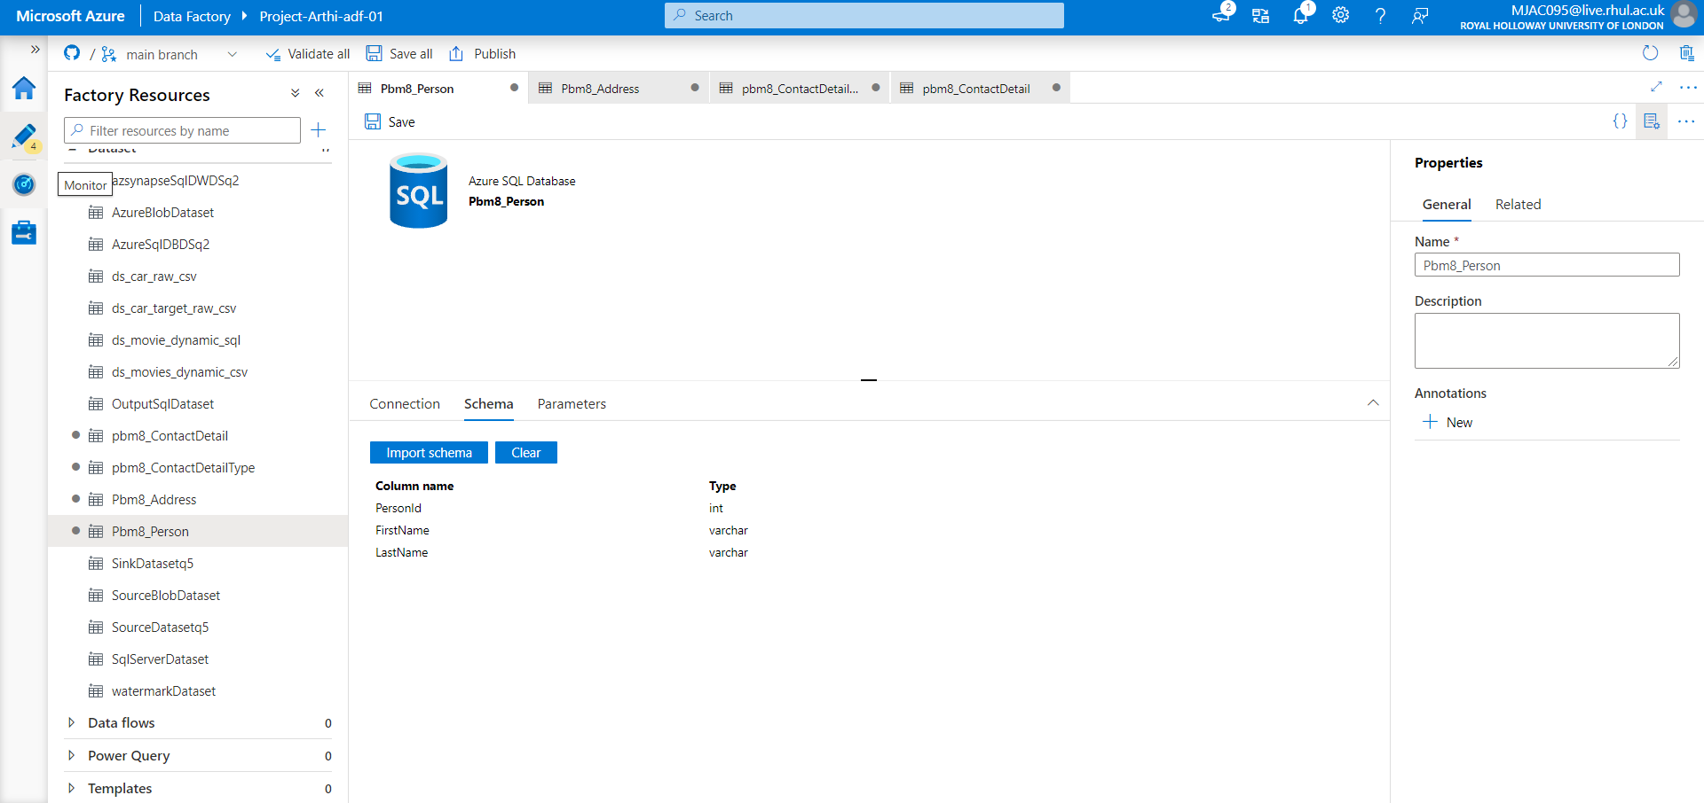

### Person - Schema:

{

    "name": "Pbm8_Person",

    "properties": {

        "linkedServiceName": {

            "referenceName": "ls_pbm8",

            "type": "LinkedServiceReference"

        },

        "annotations": [],

        "type": "AzureSqlTable",

        "schema": [

            {

                "name": "PersonId",

                "type": "int",

                "precision": 10

            },

            {

                "name": "FirstName",

                "type": "varchar"

            },

            {

                "name": "LastName",

                "type": "varchar"

            }

        ],

        "typeProperties": {

            "schema": "dbo",

            "table": "Person"

        }

    }

}

### Address - Schema:

{

    "name": "Pbm8_Address",

    "properties": {

        "linkedServiceName": {

            "referenceName": "ls_pbm8",

            "type": "LinkedServiceReference"

        },

        "annotations": [],

        "type": "AzureSqlTable",

        "schema": [

            {

                "name": "AddressId",

                "type": "int",

                "precision": 10

            },

            {

                "name": "PersonId",

                "type": "int",

                "precision": 10

            },

            {

                "name": "Line1",

                "type": "varchar"

            },

            {

                "name": "Line2",

                "type": "varchar"

            },

            {

                "name": "City",

                "type": "varchar"

            },

            {

                "name": "State",

                "type": "varchar"

            },

            {

                "name": "Zip",

                "type": "varchar"

            },

            {

                "name": "Country",

                "type": "varchar"

            },

            {

                "name": "TypeId",

                "type": "int",

                "precision": 10

            }

        ],

        "typeProperties": {

            "schema": "dbo",

            "table": "Address"

        }

    }

}

### ContactDetailType - Schema:

{

    "name": "pbm8_ContactDetailType",

    "properties": {

        "linkedServiceName": {

            "referenceName": "ls_pbm8",

            "type": "LinkedServiceReference"

        },

        "annotations": [],

        "type": "AzureSqlTable",

        "schema": [

            {

                "name": "TypeId",

                "type": "int",

                "precision": 10

            },

            {

                "name": "Detail",

                "type": "varchar"

            }

        ],

        "typeProperties": {

            "schema": "dbo",

            "table": "ContactDetailType"

        }

    }

}

### ContactDetail - Schema:

{

    "name": "pbm8_ContactDetail",

    "properties": {

        "linkedServiceName": {

            "referenceName": "ls_pbm8",

            "type": "LinkedServiceReference"

        },

        "annotations": [],

        "type": "AzureSqlTable",

        "schema": [

            {

                "name": "ContactId",

                "type": "int",

                "precision": 10

            },

            {

                "name": "PersonId",

                "type": "int",

                "precision": 10

            },

            {

                "name": "TypeId",

                "type": "int",

                "precision": 10

            },

            {

                "name": "Detail",

                "type": "varchar"

            }

        ],

        "typeProperties": {

            "schema": "dbo",

            "table": "ContactDetail"

        }

    }

}

### Screenshot 8.1.b: Query extracting People full contact info

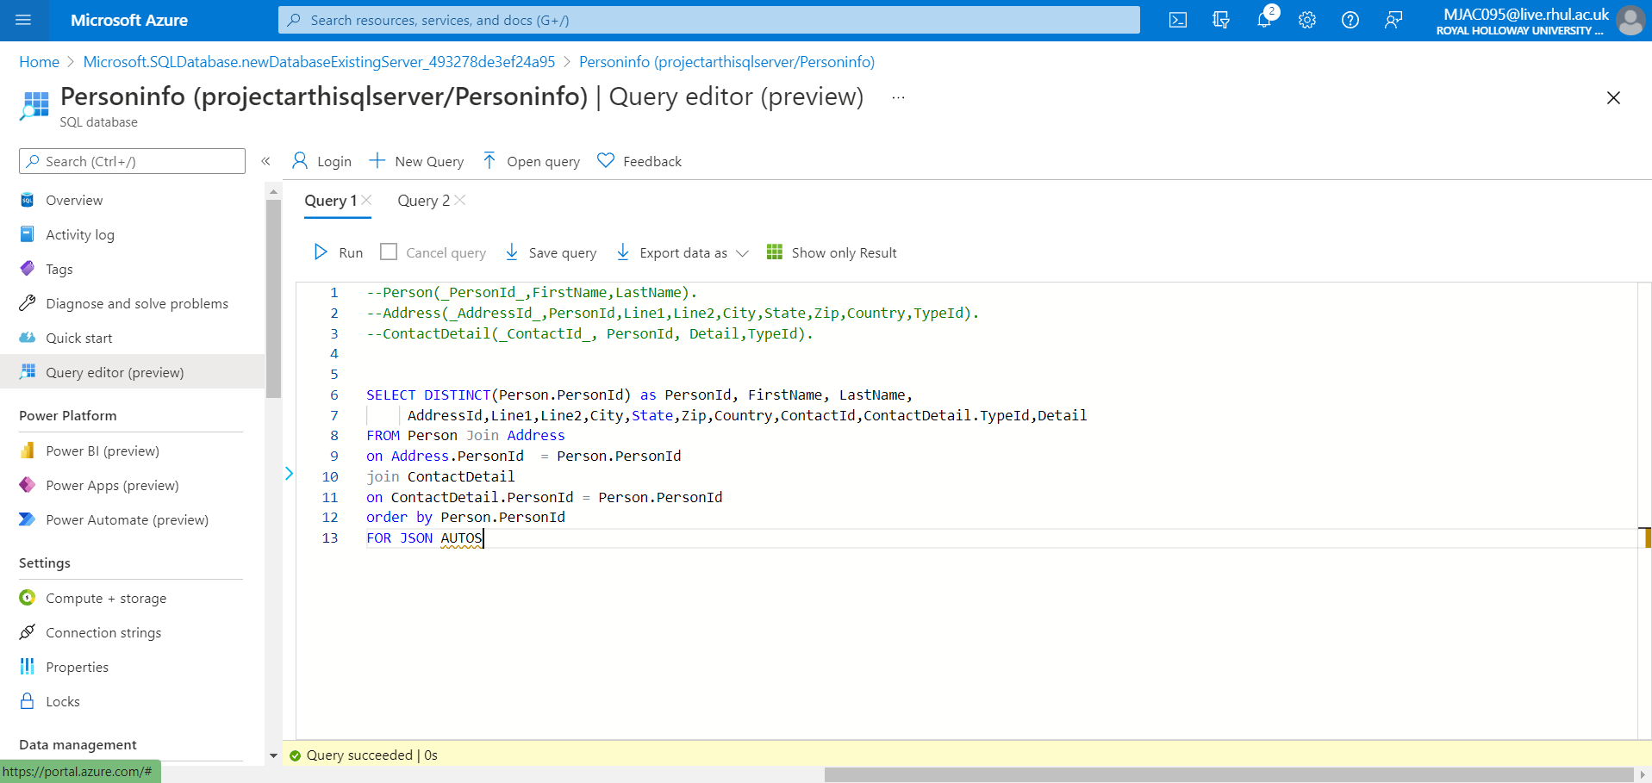

### Query:

--Person(_PersonId_,FirstName,LastName).

--Address(_AddressId_,PersonId,Line1,Line2,City,State,Zip,Country,TypeId).

--ContactDetail(_ContactId_, PersonId, Detail,TypeId).

SELECT DISTINCT(Person.PersonId) as PersonId, FirstName, LastName,

     AddressId,Line1,Line2,City,State,Zip,Country,ContactId,ContactDetail.TypeId,Detail

FROM Person Join Address

on Address.PersonId  = Person.PersonId

join ContactDetail

on ContactDetail.PersonId = Person.PersonId

order by Person.PersonId

FOR JSON AUTO

### Screenshot 8.1.c: Output in JSON FORMAT

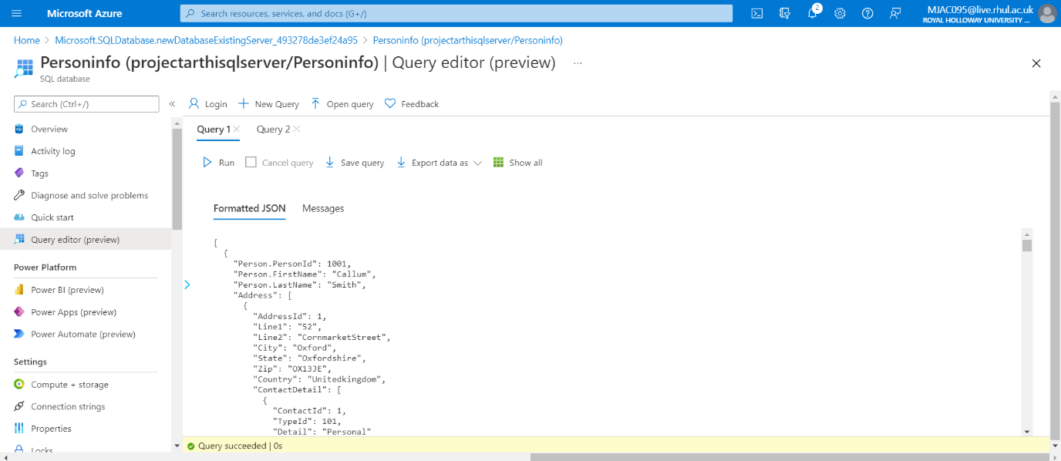

### Sample Output:

[

{

"Person.PersonId": 1001,

"Person.FirstName": "Callum",

"Person.LastName": "Smith",

"Address": [

{

"AddressId": 1,

"Line1": "52",

"Line2": "CornmarketStreet",

"City": "Oxford",

"State": "Oxfordshire",

"Zip": "OX13JE",

"Country": "Unitedkingdom",

"ContactDetail": [

{

"ContactId": 1,

"TypeId": 101,

"Detail": "Personal"

}

]

},

{

"AddressId": 11,

"Line1": "52",

"Line2": "CornmarketStreet",

"City": "Oxford",

"State": "Oxfordshire",

"Zip": "OX13JE",

"Country": "Unitedkingdom",

"ContactDetail": [

{

"ContactId": 1,

"TypeId": 101,

"Detail": "Personal"

}

]

},

{

"AddressId": 1,

"Line1": "52",

"Line2": "CornmarketStreet",

"City": "Oxford",

"State": "Oxfordshire",

"Zip": "OX13JE",

"Country": "Unitedkingdom",

"ContactDetail": [

{

"ContactId": 11,

"TypeId": 102,

"Detail": "Home"

}

]

},

{

"AddressId": 11,

"Line1": "52",

"Line2": "CornmarketStreet",

"City": "Oxford",

"State": "Oxfordshire",

"Zip": "OX13JE",

"Country": "Unitedkingdom",

"ContactDetail": [

{

"ContactId": 11,

"TypeId": 102,

"Detail": "Home"

}

]

}

]

},

Files: attached Complete output with this Project in Solution8 Folder.